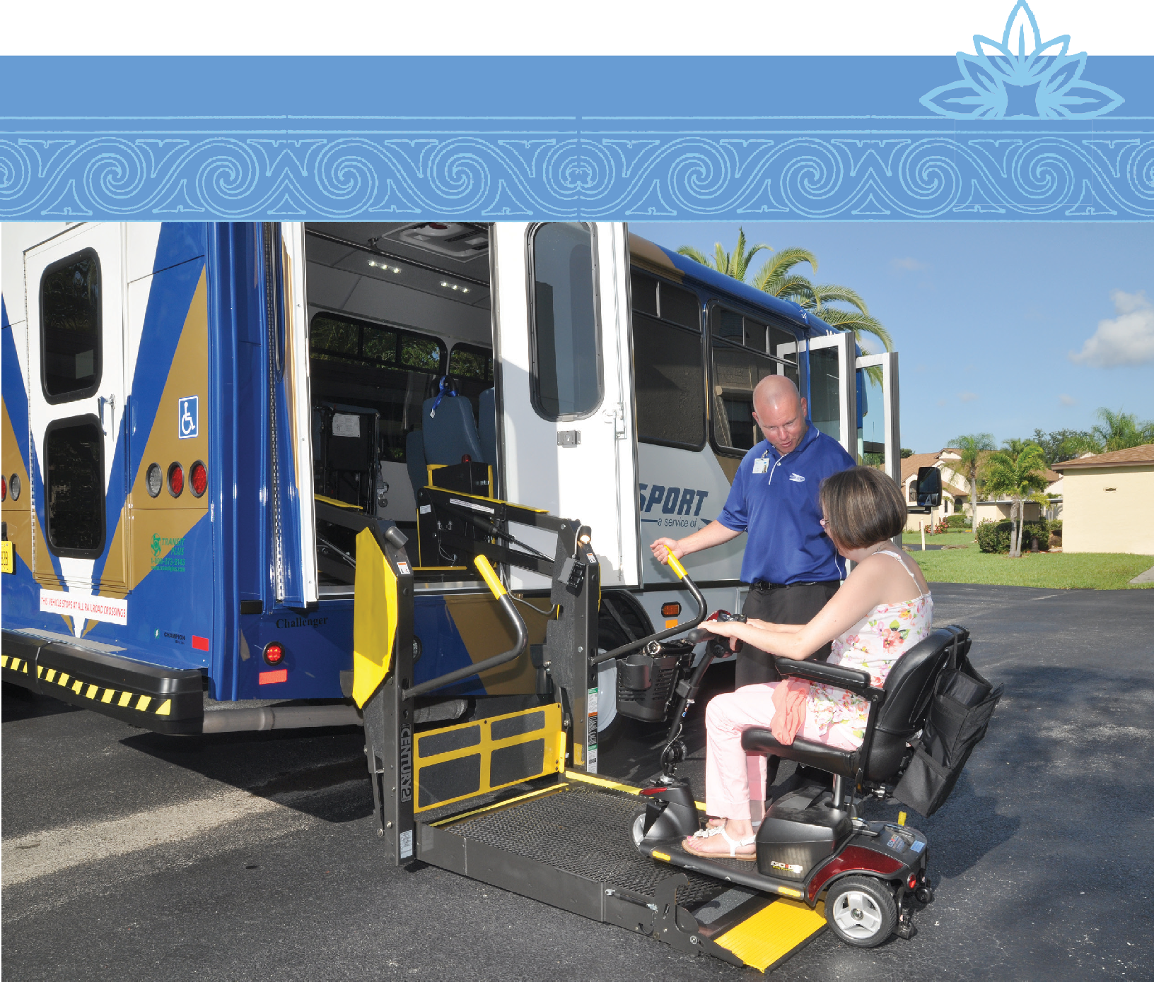

1

PASSENGER’S GUIDE

Introduction to Passport ADA Service
ADA stands for Americans with Disabilities Act. Lee County Transit’s ADA paratransit service, called Passport, is offered in strict accordance with the ADA Act of 1990. The ADA service is for persons with physical, cognitive, visual and/or other disabilities which functionally prevent them from using the LeeTran fixed route bus system either permanently or under certain conditions.

How Do I Become Eligible?
Disability alone does not confer or create eligibility for ADA paratransit. The decision is based solely on the applicant’s functional ability to use the fixed route buses. Instances where using the fixed route buses are viewed as inconvenient or an additional discomfort are not reasons for eligibility. Your disability must actually prevent you from using the fixed route buses. Eligibility for service is a transportation decision, not a medical determination.

To be eligible for service, a disability must prevent the use of the LeeTran buses, and the origin and destination of your trip must be within 3/4 of a mile of a fixed route. Origins or destinations outside of this service area are not eligible. Both of these requirements must be met before you are eligible for an ADA trip. You will be required to participate in an in-person, face-to-face assessment in order to determine your eligibility and discuss the program.

There are three categories under which a person can be eligible for ADA paratransit service:
Category 1
Eligibility includes those persons, who, because of their disability, cannot independently use a regular, accessible bus.

Category 2
Eligibility is based on the accessibility of vehicles and terminals/stops (i.e., a person is able to use the regular bus, but it is not accessible).

Category 3
Eligibility pertains to situations in which a person cannot travel independently to or from a bus stop.

A person can be given “conditional” eligibility for ADA paratransit service if they are able to use the bus under certain conditions, but not others; in those situations, eligibility will be determined according to a particular set of circumstances or conditions which pertain to a person’s disability.

If you are approved for ADA paratransit transportation, you will receive a Certificate of Eligibility ID Card and a letter outlining how to use the services. You will receive door - to- door transportation.

If no determination is made within 21 days from receipt of all completed forms, Passport service will be provided until a final determination is made.

Lee County sponsors the cost of the trip, and your transportation will cost you a $3.00 fare every time you board the vehicle. You must pay the exact $3.00 fare to the driver at the time of service, or you may be refused transportation. Drivers do not make change.

All of the vehicles sent to pick you up are ADA accessible. They will have lifts or ramps to assist passengers in boarding and loading wheelchairs. All of the drivers are trained in assisting passengers with disabilities.

If I’m denied, how do I appeal?
If you choose to appeal the decision, you must make a written request within sixty (60) days of the decision and send to the address below. An appeal review will be scheduled with applicant. If no determination of appeal is completed within 30 days, Passport service will be provided until a final determination is made.

LeeTran
C/O ADA Appeals
3401 Metro Parkway
Fort Myers, FL 33901

You will be contacted to schedule the hearing. If necessary, transportation can be provided to the hearing at no cost to you.

What types of transportation are NOT included in LeeTran’s ADA service?
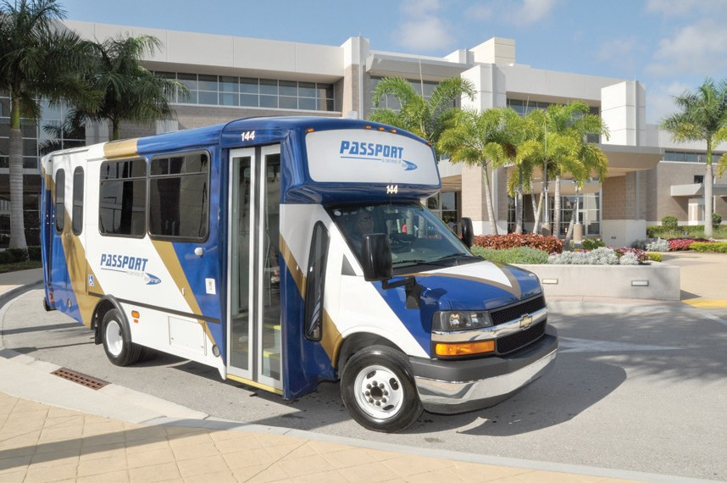
LeeTran is not the Medicaid Transportation Provider. Medicaid clients may receive their Medicaid transportation through Good Wheels or a local Florida Managed Medical Assistance Provider (MMA), depending on Medicaid program criteria. Good Wheels is a Medicaid Provider in Lee County as well as the designated Community Transportation Coordinator (CTC), under Florida Statue F.S. 427, for Lee County. Medicaid clients must call the Medicaid Enrollment Help Line for information regarding MMA enrollment, benefits, and Medicaid medical transportation at 1-800-226-6735.

LeeTran is not the CTC for Lee County, and therefore is not responsible for the Transportation Disadvantaged non-sponsored transportation program. This is a state program administered and sponsored through the Florida State Commission for the Transportation Disadvantaged (CTD), under F.S. 427, Transportation Disadvantaged Service. Good Wheels, Inc. is the CTC and provider for this service.

Please contact Good Wheels for information and enrollment. Under this program, trips are provided throughout Lee County with significantly less stringent enrollment requirements than the federal ADA eligibility. Social service agencies are also required to receive service and coordinate through Good Wheels. To contact Good Wheels, please call 1-800-741-1570 or 239-768-2900. To contact the Florida Commission for the Transportation Disadvantaged, please call 1-800-983-2435. It is strongly recommended that applicants call Good Wheels first before proceeding with the ADA application.

LeeTran is prohibited by federal regulations from providing school transportation to schools or school- related activities.

LeeTran is also prohibited from providing charter or private group services.

For additional information and to begin the application process, please call the LeeTran Passport office at 239-533-0300 between the hours of 8:00 a.m. and 5:00 p.m. Monday through Friday.

Schedule of Operations
ADA Passport service is available during the same days and hours as LeeTran’s fixed route service. In general, buses operate Monday through Saturday from 4:49 a.m. to 10:30 p.m. A limited number of routes offer Sunday service with varying end times as late as 9:03 p.m. Please check the individual route schedule that corresponds to your planned trip for exact hours of operation or for any schedule changes or adjustments. This information is available at www.rideleetran.com.

Passport service is closed on six major holidays: New Year’s Day, Memorial Day, Fourth of July, Labor Day, Thanksgiving, and Christmas. Fixed route service is also closed on these holidays. Please confirm service availability when you call.

Reservations
Eligible riders may schedule a trip on the LeeTran Passport service by calling the Passport Office at 239-533-0300, Monday through Friday, 8:00 a.m. until 5:00 p.m. For weekend service, and/or holidays, please follow voicemail instructions.

Passengers approved for Passport service are required to book their reservation at least the day before the requested trip, but cannot book a reservation more than two weeks in advance. It is permissible under ADA regulations for reservations staff to negotiate the requested pick-up time within a one-hour window before or after the passenger’s requested pick-up time. Vehicle pick-up time is based on appointment time and vehicle travel time.

When you call to schedule a trip, please be ready to provide:
- Your name and date of trip
- The time you want to be at your appointment and your return trip pick-up time
- Your pick-up address and telephone number
- Destination name, address, suite number and telephone number (due to the volume of reservations, our agents are not able to research address information)
- Whether you use a wheelchair or other mobility device
- When a personal care attendant (as indicated during the eligibility process) or guest will be riding with you, along with their name(s).
- The specific door, entrance or waiting area at which you wish to be picked up and dropped off

Visitors
Visitors who are eligible for ADA service in other cities and have documentation may use the Passport service during their visit to Lee County. Visitors who do not have documentation of ADA eligibility from another transit agency, but can provide documentation of a disability, may be eligible to use the service for up to twenty-one (21) days.
Boarding and Riding

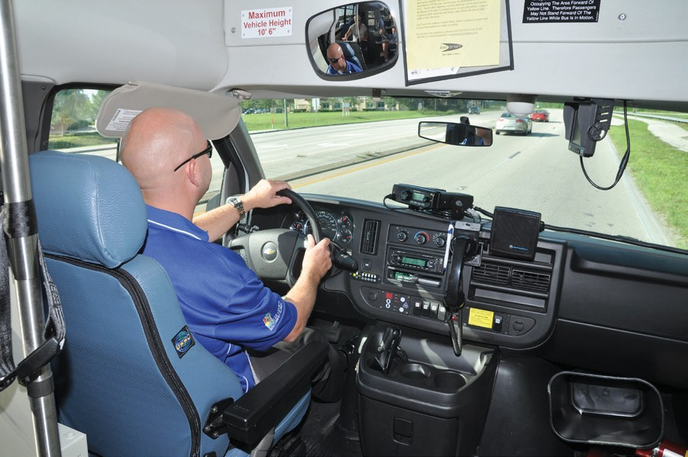
LeeTran is a shared ride system and other individuals may need to be scheduled on the same vehicle. It may be necessary to get to an appointment a little early or picked up from a return a little later than requested. LeeTran will make every effort to offer a pick up and drop off time that is as close as possible to the times requested. Passengers are required to be ready up to one (1) hour before their drop-off (appointment) time. For longer, cross-county trips, you may be required to be ready up to 90 minutes before. The driver may arrive within thirty (30) minutes (Pick Up Window) after your scheduled pick up time. Passengers may be dropped off up to thirty (30) minutes prior to their requested drop off (appointment) time. For the return trip, the driver may arrive up to thirty (30) minutes after your requested return pick-up time (Pick Up Window).

Passport is door-to-door transportation. Drivers are not permitted to lose sight of their vehicle or leave their vehicle unattended with passengers on board longer than 15 minutes. If a passenger lives in an apartment building, adult care living facility, nursing home, or similar place that has a common lobby, the passenger is required to meet the driver in the lobby. The passengers are to be fully dressed and ready to board the vehicle. Drivers are not allowed to assist passengers in dressing. Drivers are not allowed to lift, carry or load passengers into their mobility devices (i.e., wheelchair, scooter, etc.). Passengers may board the vehicle either via lift, ramp or doorway. Drivers will assist riders when entering and leaving the vehicle. This includes offering a steady arm when walking, assisting in bringing the rider’s wheelchair or other mobility device to and from the main door, or if requested, assisting with unlocking and/or opening a main entrance door of the building or residence. Drivers are not allowed to enter residences or take wheelchairs up or down more than one step.

For safety, passengers are to wait for the drivers instructions before exiting the vehicle. Passengers are not to unfasten their mobility devices or move their mobility devices without prior instructions from the driver.

If the destination is in an office complex, hospital, or has a common lobby, drivers will leave the passenger in the lobby. The following are the standard entrances for main destinations.

Standard Entrances

Bell Tower Shops Bed, Bath & Beyond, Regal Cinemas and Fresh Market
Cape Coral Hospital ER, Women’s &Children’s Entrance or Main Entrance
Edison College Parking Lots 2 and 5, & Barbara B Mann Hall
Edison Mall Valet Entrance and Entrance G
Fleamasters Flea Market Customers Service building @Main Entrance, Gate 1 and Gate 8
Florida Gulf Coast University Transit Bus Stop and Alico Arena
Gulf Coast Hospital Front Main Entrance or ER, & Birthing Suites
Gulf Coast Medical Bldg. Main Lobby facing Hospital
HealthPark Hospital Entrance B, Emergency Room and Loading Dock
Health Park Medical Bldg. Main Lobby
Lee Memorial Hospital Main Entrance or ER
Lee Memorial Doctors Bldg. Lobby by Valet Parking
Miromar Mall Ford’s Garage and Bloomingdales
Target Food Entrances
Walmart Food Entrances

Being On Time
Passport vehicles are required to announce themselves and wait for the passengers five (5) minutes after their arrival time. If an individual has not boarded the vehicle within five (5) minutes after the vehicle arrives, the driver will contact dispatch to request permission to mark the trip a No Show. If the trip is beginning at the residence, dispatch will make an attempt to call the passenger. Once approved by dispatch, the driver will leave a No Show Door Hanger Notice then the vehicle will depart and a “no show” will be assessed to the passenger’s record. If the trip is the originating trip of the day (first trip of the day), a vehicle will not be sent back. Exceptions are made if there was an error in scheduling or the driver was at the wrong location. See No Show section for more information.

Transporting Packages, Oxygen, Etc.
Passengers are to limit their packages to four (4) small parcels that they can carry. Drivers are not allowed to assist riders with personal belongings. If you have difficulty handling your packages, please bring a personal care attendant or guest to assist you. Under limited circumstances the passenger may request the driver to assist with their belongings. However, the driver must be able assist the passenger and carry the items in one trip. Personal, two-wheeled, collapsible grocery carts are permitted and encouraged. Large coolers are not permitted. Small animals in designed pet travel cases are permitted, as long as the passenger is able to carry the pet travel case. Any packages or objects belonging to passengers cannot block aisles or emergency exits. It is important to remember that Passport is a shared-ride system. Passengers may not transport potentially dangerous items, explosives, flammable liquids or materials that are hazardous to themselves, drivers or other passengers. Passengers possessing or using illegal drugs may be denied or terminated from transportation. Passengers using self-carrying portable oxygen are granted transportation, as it is a life-sustaining mobility aid.

Service Animals
A service animal is defined as an animal trained to work or perform tasks for an individual with a disability. Service animals may ride at no additional charge, but must be properly controlled. Service animals must remain at the owner’s feet or on the owner’s lap. A service animal cannot sit on a vehicle seat or obstruct aisles, doors and steps in order to facilitate safe boarding. Passengers are responsible for the behavior and hygiene needs of the service animal. Service can be refused or discontinued if a service animal is seriously disruptive or violent.

Wheelchairs, Scooters and other Mobility Devices
LeeTran vehicles are designed to accommodate wheelchairs and other mobility devices. As long as the passenger is able to safely navigate the manual or motorized mobility aid on and off of the ramp or lift without exceeding the manufacturer’s maximum weight limit, LeeTran can transport the device. Passengers that are able to, may board separately than their device in instances where the weight limit may be exceeded. If your wheelchair or mobility device exceeds the size that can be accommodated on a wheelchair lift or ramp or cannot fit within the securement area in the vehicle, transportation with LeeTran service may be denied until you are able to obtain a mobility device that meets these criteria.

Wheelchair Securement and Seat Belt Policy

It is the driver’s responsibility to ensure that mobility devices are properly secured. All wheelchairs and scooters must be secured in the vehicle’s four point securement system at all times during the ride. All individuals are required to comply with Florida’s seatbelt law.

LeeTran Passport No Show/Late Cancellation Policy

LeeTran understands that because Passport service requires trips to be scheduled in advance, riders may sometimes miss scheduled rides or forget to cancel rides they no longer need. Passport also understands that riders may sometimes miss scheduled trips or be unable to cancel trips in a timely manner for reasons that are beyond their control. However, repeatedly missing scheduled trips or failing to cancel trips in a timely manner can lead to suspension of service. The following information explains Passport’s No Show policy.

No Show
A No Show occurs when a rider fails to appear to board the vehicle for a scheduled trip. This presumes the vehicle arrives at the scheduled pickup location within the pickup window and the driver waits at least five minutes.

Pickup Window
The pickup window is defined as 30 minutes after the scheduled pickup time. Riders must be ready to board a vehicle that arrives within the pickup window. The driver will wait for a maximum of 5 minutes within the pickup window for the rider to appear.

Late Cancellation
If you know that you will not need a scheduled trip, please cancel it as early as possible to make sure scheduling is available for other passengers. A late cancellation is defined as either a cancellation made less than 2 hours before the scheduled pickup time, or a cancellation made at the door, or refusal to board a vehicle that has arrived within the pickup window.

Circumstances Beyond the Rider’s Control
No Shows or late cancellations are not counted when there are situations beyond the rider’s control that prevent the rider from notifying us that the trip cannot be taken, such as:
- Medical emergency/hospitalization;
- Family emergency;
- Sudden illness or change in condition; or
- Appointment that runs unexpectedly late without sufficient notice

No Shows or late cancellations are not counted when the missed trip is due to our error, such as:
- Drivers arriving and departing before the pickup window begins
- Drivers arriving late (after the end of the pickup window)
- Drivers arriving within the pickup window, but departing without waiting the required five minutes.

Subsequent Trips Following No Shows or Late Cancellations
When a rider has a No Show or late cancellation for a trip, all subsequent trips on that day remain on the schedule unless the rider specifically cancels the trips. To avoid multiple No Shows or late cancellations on the same day, riders are strongly encouraged to cancel any subsequent trips they no longer need that day.

Percentage of No Shows
Frequency of trips along with the number of missed trips will be used to determine a no show percentage rate.

At the end of the month, those passengers who have been recorded as having 2 (two) or more No Shows will be reviewed to identify the passenger’s trip and No Show history as well as their frequency of travel. Each No Show will be verified to determine circumstances of the missed trip.

Suspension Policies for a Pattern or Practice of No Shows or Late Cancellations
Passport reviews all recorded No Shows and late cancellations to ensure accuracy before recording them in a rider’s account.

Riders will be subject to suspension under the following conditions:
- Schedule 10 or more trips within a calendar month and have No Shows or late cancellations totaling 10% of their trips; or
- Schedule less than 10 trips within a calendar month and have No Shows or late cancellations totaling 30% of their trips.

Initially, a warning letter will be issued to try to modify the behavior. If the problem continues, a progressive suspension length will be as follows:

- First Suspension will be for five days;
- Second Suspension will be for 10 days;
- Third Suspension will be for 15 days; and
- Four and any subsequent Suspensions will be for 30 days.

Policy for Disputing Specific No Shows or Late Cancellations
Riders wishing to dispute specific No Shows or late cancellations must do so within 30 days of receiving suspension letters. Riders should contact the ADA Fiscal Officer at (239) 533-0351 to explain the circumstance, and request the removal of the No Show or late cancellation.

Policy for Appealing Proposed Suspensions
Riders wishing to appeal suspensions under this policy have the right to file an appeal request, which must be in writing by letter or via email. Riders must submit written appeal requests within 60 days of receiving suspension letters. Riders who miss the appeal request deadline will be suspended from Passport on the date listed on the suspension notice. All suspension appeals follow Passport’s appeal policy.

How to Avoid No Show/Late Cancellation Situations
- Review times and dates with the Passport reservationist or dispatcher to be sure you understand the 30 minute pickup window and when to expect the bus.
- When you no longer need the ride, call Passport, 239-533-0300 option 2, immediately to let them know the ride is no longer needed.
- Remember to cancel all trips scheduled for that day. If all trips are not cancelled, you will be charged a No Show for the remaining trips on the schedule.
- Be prepared to board within 5 minutes of the arrival of the vehicle.

Fares
Passengers are required to pay a fare for Passport transportation before they can ride. The current fare is $3.00 per trip. The fare is subject to change. The fare charged to an ADA eligible user shall not be more than twice the fare that would be charged to an individual paying full fare (without regard to discounts) for a trip of similar length, at a similar time of day, on Lee County Transit’s fixed route system. In calculating the full fare that would be paid by an individual on the fixed route system, LeeTran may include transfer and premium charges applicable to a trip of similar length, at a similar time of day on the fixed route system. ADA regulations 49 CFR, Part 37, Section 37.131 allow transit agencies to charge a higher fare to a social service or other organization for agency trips.

The fares for any passengers accompanying ADA eligible individuals shall be the same as for the ADA eligible individuals they are accompanying, with the exception of Personal Care Attendants. Passport passengers may take Personal Care Attendants (PCA’s) with them. A PCA is defined as an individual who is medically necessary to aid an ADA passenger. A Passport passenger must be pre-approved to take a PCA. PCA’s do not have to pay a fare to ride Passport.

Passport passengers may also bring guests with them. Guests must pay the regular Passport fare to ride. A guest can be anyone who wishes to ride with the passenger.

When booking a trip, each passenger must tell the reservationist if a PCA or a guest will be accompanying him or her. At the time the reservation is made, the passenger must provide the number of people traveling with him/her, and if they will have any mobility aids (i.e., wheelchair, walker, oxygen, etc.) with them on their trip.

Passport tickets may be purchased in advance by calling 533-0300, by mail, or by visiting the Passport office between the hours of 8 a.m. and 5 p.m.

Subscription Service
A subscription trip is a trip that is regularly repeated between the same origin and destination and at the same times.

Passengers that utilize Subscription Service must call in and cancel their trips when taking vacation or when other circumstances cause the passenger to not need the trip. If the passenger No Shows a Subscription Trip more than three (3) subsequent trips in a row, the standing order will be cancelled until the passenger calls to confirm that they still need a Subscription Trip.

Subscription Service is not a requirement of the ADA. ADA regulations 49 CFR, Part 37, Section 37.133 permit transit agencies to establish waiting lists or other capacity controls and trip purpose restrictions (e.g., work trips only) or priorities for participation in the subscription service. Subscription Service may not absorb more than fifty (50) percent of the number of trips available at a given time of day, unless there is non-subscription capacity.

Rules of Behavior
- Pursuant to the Florida Clean Air Act (F.S. 386), smoking in public vehicles is strictly prohibited. ADA transportation is a shared-ride system, in which people with various disabilities ride with other passengers. Some passengers may require oxygen, while others may be medically fragile. Smoking is therefore prohibited on all ADA Passport vehicles. If such an occurrence happens, a hearing with the ADA Disciplinary Committee may be scheduled.

- Exact fare must be paid when boarding. Drivers do not make change.

- Eating and drinking are prohibited in all Lee County Passport vehicles (unless medically needed).

- No littering in the vehicles.

- No radios, MP3 players or CD players, or sound-generating equipment are to be played aloud aboard the vehicle. Riders must use earphones or headphones when using these types of devices.

- All passengers are required to wear seatbelts including shoulder belts for wheelchair clients, while being transported in Lee County Passport vehicles.

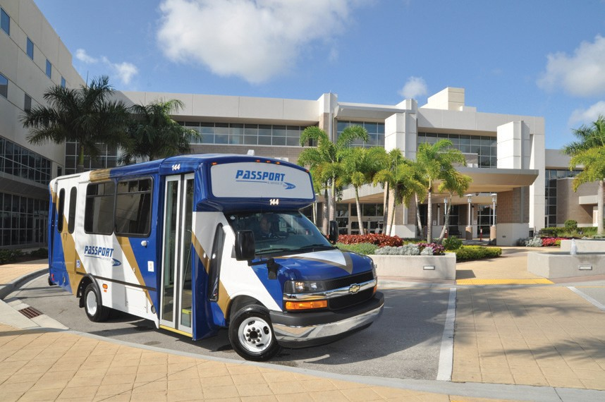
- Unscheduled stops are not allowed (i.e., stopping at convenience stores for drinks, stopping at pharmacies for prescriptions, etc.). Drivers are only allowed to make stops at destinations listed on their manifests.

- Passport cannot make same-day changes to reservations.

- Violent, disruptive or illegal behavior will not be tolerated. Passengers who are physically or verbally abusive to drivers or other passengers, or are otherwise disruptive, will be subject to disciplinary actions which may lead to suspension of service. If necessary, LeeTran staff will contact the appropriate law enforcement authorities to have a disruptive individual removed from the vehicle. ADA regulations 49 CFR, Part 37, Section 37.5(h) allow transit agencies to refuse service to an individual that engages in violent, seriously disruptive or illegal activity.

- Due to safety concerns, Passport may modify the exact pick-up or drop-off location.

Disciplinary Committee
On occasion, when there are transportation or passenger problems, a disciplinary committee will meet to review such matters. The disciplinary committee consists of representatives of Lee County Transit, Lee County’s Office of Equal Opportunity, and two passengers of Passport transportation. The disciplinary committee meets on a case-by-case basis, but may meet monthly if the need demands that it does so.

Premium Service
Premium Service is designed to allow ADA eligible passengers to travel outside of the ADA ¾ mile service area and extended hours and service days outside of the regular fixed route schedules. Premium reservations are only allowed to be booked two days in advance. Trips are limited and on a first come, first serve basis.
- Premium Fare: $6
- Premium Hours of Service: 5am to 10pm
- Premium Service Days: 7 days a week
- Please Contact Reservations for more information.

ADA Complaints, Service Related Complaints or Suggestions
All complaints should be reported to Lee County Transit (LeeTran). Please be specific and give relevant details regarding the trip. Share concerns about specific rides or incidents as soon after the actual occurrence as possible. Every complaint will be investigated.

For any complaint received directly by Passport Staff, the complaint follow-up shall be handled in the following manner:

All complaints received will be entered in to the Complaint/Request for Action database. All complaints received either by phone, mail, e-mail, and fax or in person will be entered in to the Complaint/Request for Action database to initiate an investigation into the complaint. Written and faxed complaints will be scanned and attached to the electronic complaint file. If a complainant does not want to be contacted by Passport, please indicate so. For any written complaint or voicemail complaint received, a verbal acknowledgment will be made within two (2) business days to the customer to inform the person that their complaint is being investigated. Within fifteen (15) working days a follow-up letter will be sent to the individual filing the complaint to give the resolution to the complaint and determine if the problem has been resolved to the person’s satisfaction. At the discretion of the Operations Manager, and depending on the severity of the complaint a verbal response may replace the written response and this will be documented in the complaint file.

Contact us at:
Passport, a Service of LeeTran
3401 Metro Parkway Fort Myers, FL 33901
239-533-0300
Online: http://www.leegov.com/rfa
Email: rideleetran@leegov.com

Reasonable Modification
Requests for modifications of LeeTran’s policies, practices, or procedures to accommodate an individual with a disability, may be made either in advance or at the time of the transportation service. LeeTran is best able to address and accommodate a request when customers make their requests for modifications in advance.

Requests may be made through the following means:
- Call (239) 533-0300 ext 30354.
- Passport customers may make requests at the time of booking their trips.

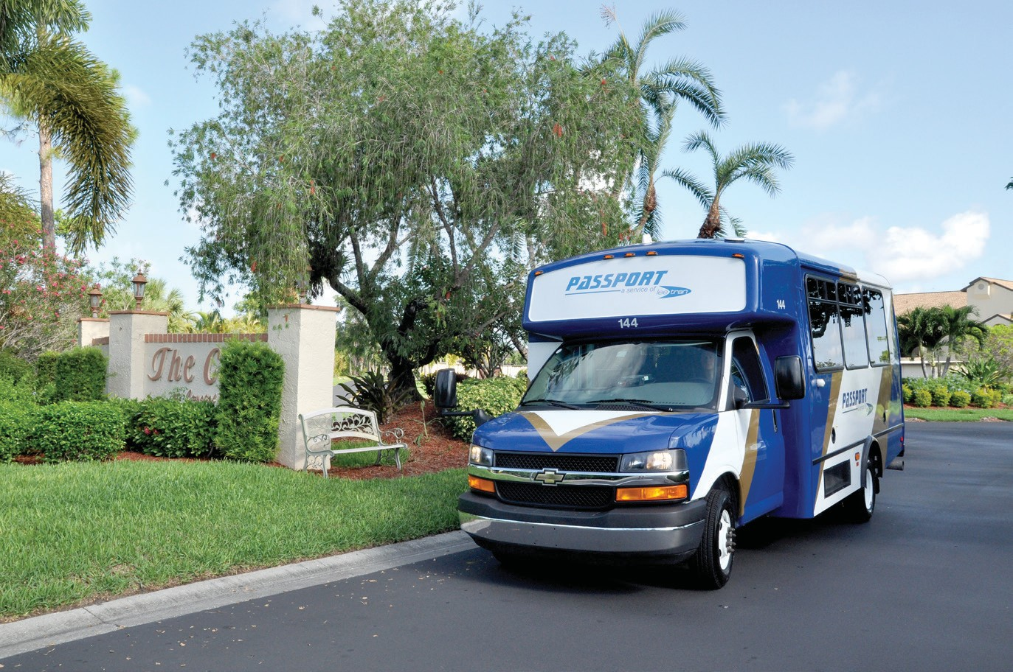

3401 Metro Parkway Fort Myers, FL 33901
Fax: 239.432.2035
Florida Relay Service-Dial 711 for TTY assistance and other available services.

*LeeTran complies with Title VI of the Civil Rights Act of 1964 which prohibits discrimination on the basis of race, color or national origin. If you feel you have been discriminated you may file a complaint by calling LeeTran at 533-8726 or Lee County’s Office of Equal Employment Opportunity 533-2245.

Accessible format is available upon request.
Revised 3/9/2017

