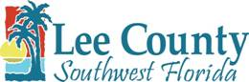

Lee County Utilities

Developer Contributed Asset Project

Letter of Completion

Date:

Lee County Utilities
1500 Monroe Street
Fort Myers, FL 33901

Gentlemen:

This is to certify that the

located
(Name of Development/Project)

designed by me and been constructed in conformance with:
and

Upon completion of the work, we observed the following successful tests of the facilities:

Very truly yours,
(Name of Engineering Firm)
(Engineer of Record’s Signature)

(Seal of Engineer of Record)

(Engineer of Record’s Name and Title)

