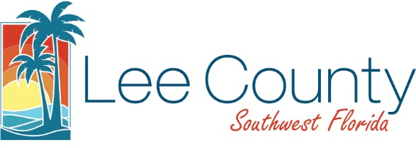

LEE COUNTY UTILITIES

REQUEST FOR LETTERS OF AVAILABILITY
 |  |  |  |  |  | Date: July 29, 2026
To: DCAP Staff |  |  |  |  |  |  | From:
Lcudcap@leegov.com |  |  |  |  |  |  | Firm:
 |  |  |  |  |  |  | Address:
 |  |  |  |  |  |  | Address: , -
 |  |  |  |  |  |  | Phone#: ( ) - Fax: ( ) -
 |  |  |  |  |  |  | E-Mail Address:
Project Name:
Previous Project Name(s):
Strap Number(s):
Prior Strap Number(s) (If Any):
Location/Site Address:

Purpose of Letter:
Development Order Submittal Financing Effluent Reuse
Permitting of Surface Water Management (South Florida Water Management District)
Other: (Please Specify)
Planned Use:
Commercial Industrial Residential - (Single-Family Multi-Family)
Other: (Please Specify)
Planned # of Commercial/Industrial Buildings: Total Square Footage:
Residential Units: Single-Family: Multi-Family:
Average Estimated Daily Flow (GPD): ( Water Waste-water) (GPD): Reuse
Please show calculation used to determine Average Estimated Daily Flow (GPD) per Criteria set forth in Lee County Utilities Design Manual:

Please e-mail the completed form to Lcudcap@leegov.com.
If you should have any questions or require assistance, please feel free to call our office at (239) 533-8531.

