Greater Insight Carrier User Manual

Aon Hewitt’s Request for Proposal (RFP) Platform  
May 2015



Table of Contents

Welcome 3

Accessing Greater Insight 3

Greater Insight RFP Help/Carrier Support 4

How to Add a User to Greater Insight 4

What’s New 4

Notification of an RFP 5

Accessing the RFP 5

Responding to an RFP 6

Prepare Bid 7

Responding to the Design(s), Rate(s), and Additional Items 8

Questionnaire(s) 9

Adding Documents 11

Review and Submit 11

Answer Library 13

Entering Information Into the Answer Library 13

Document Library 14

Loading Documents into the Document Library 15

Aon Charter 15

Our Values, Our Strengths, and Our Commitments 17

Your Commitment 18

# Welcome

We are pleased to present this comprehensive guide to our Greater Insight Broking Platform. You will find that this system serves as a vital tool for communication among your teams and with the Aon teams. This guide will show you the basics of navigation and how to respond to a RFP.

# Accessing Greater Insight

Greater Insight is an online tool that can be accessed via the internet.* You will need to be added to the system to receive a User Name and Password. Once added, you will have access to all RFP’s that have been sent or assigned to you within your organization.

* The link to Greater Insight is: [https://greaterinsight.aon.com](https://greaterinsight.aon.com/)
* Once you have been added to Greater Insight, your first attempt to access the site will require a username and email address associated to your company in order to create a new personal password for access. In order to do this, click on link ‘Forgot Your Password/First Time User?'’

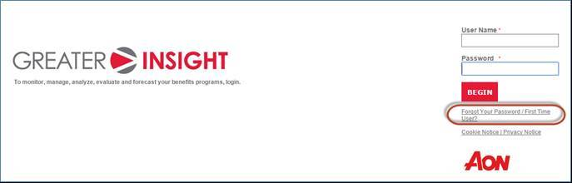

*Recommended browsers for optimal performance on Greater Insight tool:

Firefox

Google Chrome

Greater Insight RFP Help/Carrier Support

Please see the below Vendor Support contact information:

Greater Insight RFP Carrier Support Team

|  |  |  |
| --- | --- | --- |
| **Line of Coverage** | **Email address** | |
| * Medical | | [GI.RFP.Help@aonhewitt.com](mailto:GI.RFP.Help@aonhewitt.com) |
| * Life * Disability * Dental * Vision * Stop-Loss * Elective Benefits * Critical Illness * Accident * Hospital Indemnity * Permanent Life * Group Auto * Group Home * Group Legal | | [hbspssupport@aon.com](mailto:hbspssupport@aon.com) |

# How to Add a User to Greater Insight

* Please specify the following information in an email to the appropriate Greater Insight RFP Carrier Support Team address listed above:
  + New User’s Name
  + New User’s Email Address
  + Name of Carrier
* Once the above information has been sent to Aon, the new user will receive an email containing their personal Greater Insight Username and directions on how to create a password upon setup.

# What’s New

Greater Insight has an updated look with added features to improve usability of the tool:

* At a Glance—provides a summary of key RFP details
* Menu ~~of~~ on the Left
* Completed RFPs—gives you access to all completed RFPs
* Answer Library—stores common responses to RFP questions (former ‘Question Library’)

# Notification of an RFP

When you have been assigned to a RFP, an email will be sent from Greater Insight containing the information on the following page. This is your notification that an RFP is available within Greater Insight.

*“Example RFP has been published and is ready for view. Please make note that Round 1 begins on mm/dd/yyyy and ends on mm/dd/yyyy. Please have all bids submitted by mm/dd/yyyy.”*

You are now ready to log in.

# Accessing the RFP

When you first log in you see the **RFP Listing** page—a grid listing all the RFPs/Renewals that are active and assigned to your organization. To access an RFP, click on the RFP Name.

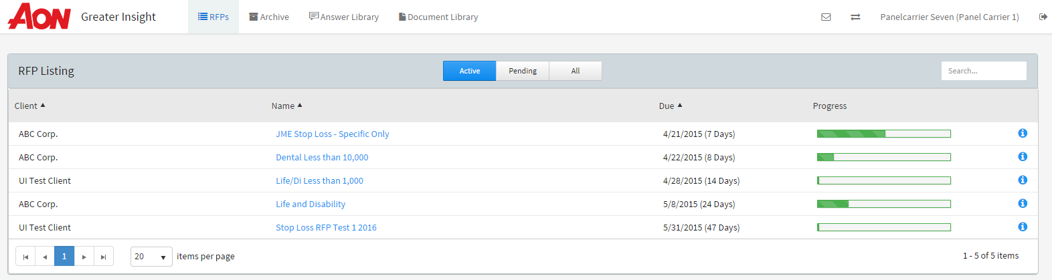

* RFP Listing: navigation on the RFP homepage includes:
  + **Active:** All RFPs that are active (and have not been submitted by your organization) and are within the round due date.
  + **Pending:** All RFPs that have been submitted to Aon but client decisions have not made in the system. RFPs in a status of ‘Failed to Quote’ would also be listed here.
  + **All**: All RFPs that are either Active or Pending.
  + **Search:** Allows for the ability to search by client or RFP name.
  + **Client**: Name of the client assigned the RFP.
  + **RFP Name**: Name of the RFP and also allows you to open the RFP.
  + **Due:** The date the RFP is due from your organization. The number of days next to the due date provides the number days still remaining until the round closes.
    - If the due date is highlighted red it is within one day of the due date.
    - If the due date is highlighted yellow it is within five days of the due date.
  + **Progress**: Indicates the percentage of the RFP that is complete. Hovering over the % complete will show the user information about the components completed out of the total required components to reach 100%
  + : Provides **‘At a Glance’** information for selected RFP, including information such as the round end date and time, contact details, access to the RFP Summary document, Objectives, Scoring Criteria, and any Reference Documents.
* Additional navigation at top of this page includes:
  + **Completed RFPs:** All RFPs that are completed and client decisions have been made.
  + **Answer Library:** Ability to store default answer templates to the Questionnaire or Design sections of the system.
  + **Document Library:** Ability to store non client specific documents that can be imported into any RFP.
  + **User Inbox**: Stores all RFP reports that have been generated in the system.
  + **User profile:** Indicates which user is logged into Greater Insight.
  + **Logout:** Allows you to log off the site. Responding to an RFP

# Responding to an RFP

* Review RFP:
  + After selecting the RFP from the RFP Listing page, the **Review** page launches to display information for you to review about the RFP.  
     ***Note****: You’re guided through the RFP process step by step via the arrow icons which are highlighted in blue to indicate which step you are viewing. You can also click on any of the arrow icons at any point during the RFP process to access that specific page. . The**icon next to the arrows indicates if information is incomplete. A* *indicates that all necessary information has been completed.*
* **Client Information:** Shows details about the client; for example, SIC Code, Address, and   
  Eligible Lives.
* **RFP Summary:** Provides summary information about the entire RFP; for example high level plan summary, overview of supporting documentation, Aon contact information.
* **Reference Documents To Review:** Provides the supporting documentation that should be reviewed to respond appropriately to the RFP.

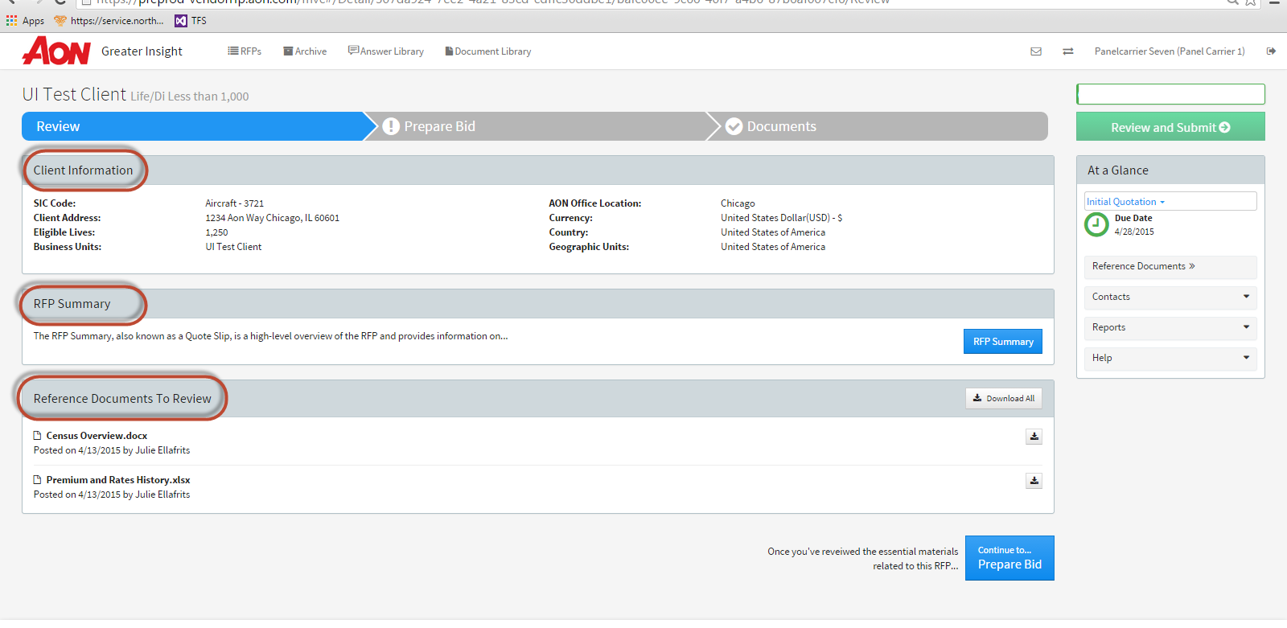

* **Progress Bar:** Similar to the RFP Listing page, the progress bar shows the percentage of the RFP that is complete. Again, the user can hover over the percentage bar to see how many components they have completed and how many remain to reach 100%.
* **At a Glance:** Similar to the RFP Listing page, the At a Glance section provides the following information:
  + **Due Date:** The date the RFP is due from your organization. The number of days next to the due date provides the number days still remaining until the round closes.
  + **Reference Documents:** Same as the Document to Review section, this link will provide all the supporting documentation that should be reviewed to respond appropriately to the RFP.
  + **Contacts:** Lists the AON and Vendor contacts. Select to email the contact directly.
  + **Reports:** 
    - **Bid Comparison:** This report is available after you have submitted your bid. It will provide a high-level summary of your response.
    - **Template Extract:** This report is available at any time and provides an excel extract of the entire RFP. As you enter your responses the Template Extract will also record your responses and provide a summary of your quote.
  + Help:
    - **Ask A Question:** The ability to ask a question about the RFP and see answers to your questions provided by the Aon Broking team.
    - **FAQ:** Frequently asked questions about the RFP will be posted with answers.

# Prepare Bid

After reviewing the information provided about the RFP, you can choose your bid decision (Bid, Bid With Changes, or Decline Quote). You do this by clicking on the **Prepare Bid** icon. If there are multiple designs per product, the user can click on Bid All, Bid All with Changes, or Decline All to respond in bulk.

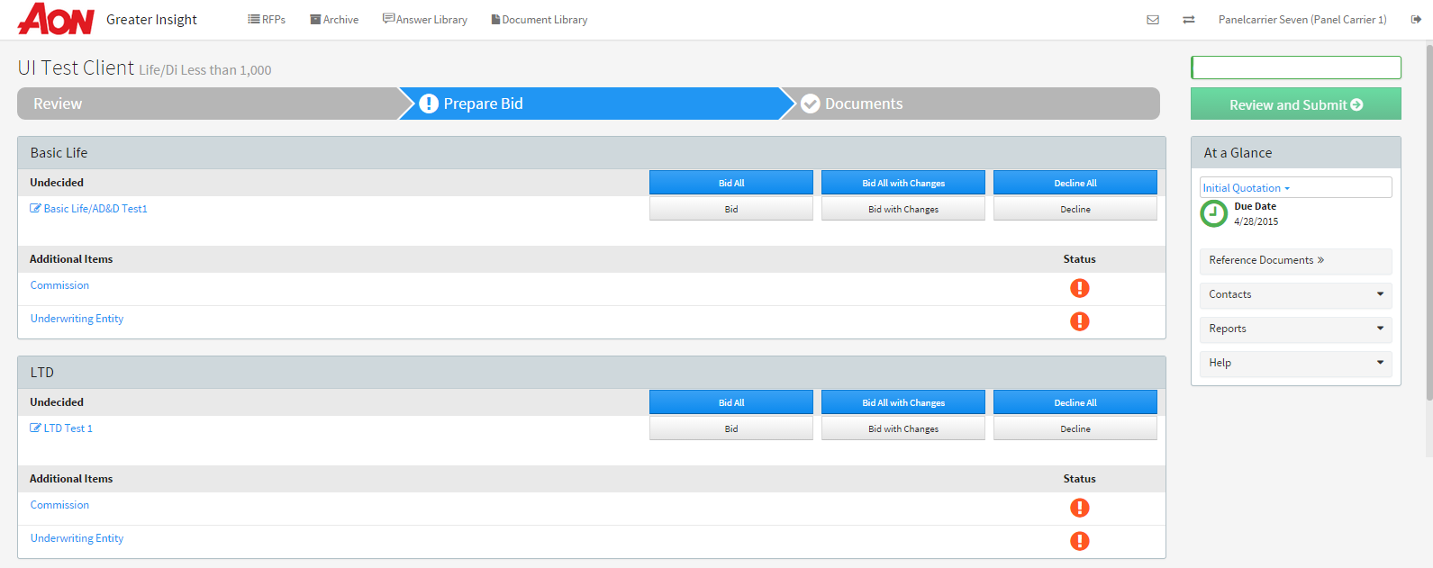

* **Bid All:** This selection indicates you will bid on all designs listed within that product. When you choose to ‘Bid All’ on the designs you are agreeing to bid on all designs as-is and do not expect to make changes to the design.
* **Bid:** This selection allows you to Bid as-is with no changes to the design.
* **Bid All With Changes:** This selection indicates you will bid with changes on all designs listed within that product. If you choose to bid on all designs but would like to change all designs then you would choose this option. User can import default answer templates stored in the Answer Library.
* **Bid With Changes:** This selection indicates you will bid on the individual designs but make changes to the design. User can import default answer templates stored in the Answer Library.
* **Decline All:** This selection indicates you decline to bid on all the designs with that product.
* **Decline:** This selection indicated you willDecline to bid on individual designs.

# Responding to the Design(s), Rate(s), and Additional Items

There are two ways to complete the Design, Rates, and Additional Items. You can start from the **Prepare Bid** or you can respond design-by-design by clicking on the name of the design on the left side of the page.

When a section is completed successfully you will see a green check

If a section hasn’t been accessed or is incomplete you will see an orange exclamation

When starting from the **Prepare Bid** page, you will choose your bid decision by clicking on the Bid, Bid With Changes, or Decline button. From there you’ll complete the appropriate sections by clicking on the icons within Design, Rates, or Additional Items.

As you complete each section you’ll see the  change to. Once you’re 100% complete with the RFP, you’ll be able to Review and Submit your bid.

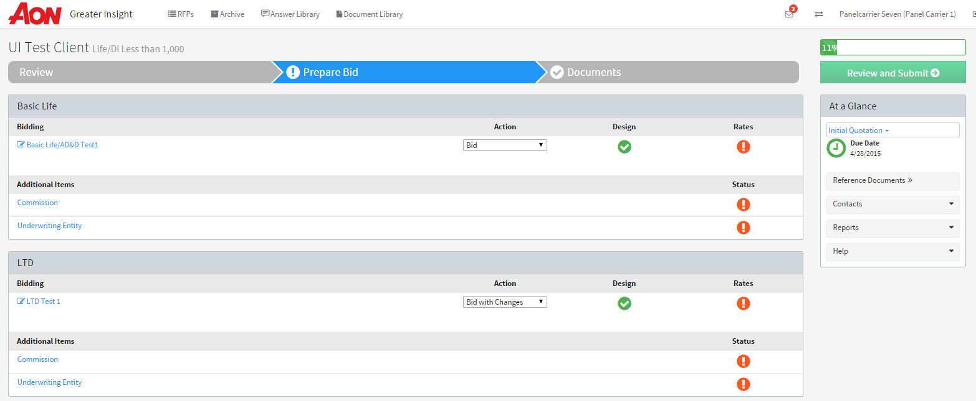

When starting from within the **Design** you’ll click on the name of the design and choose your bid decision from there. You’ll complete each section by clicking on the sections within the left-side navigation bar. A design comment next to the design name will provide additional context or specific important information for the insurer.

* **Rates:** Accessed via the Prepare Bid screen or within the Designs page—they can be accessed by clicking on the Rate name in the menu on the left side of the page. If there are many employee classes, the user can click “Copy Class” to propagate the same rate across multiple classes.
* **Additional Items:** Includes Commissions, Financials, and Standard and Non-Standard Fees, and Underwriting Entities. These additional items will be displayed underneath the Products and Designs they are associated with. Similar to Rates and Designs, users can access these entities either via the Prepare Bid screen or within the Designs page. Users will be prompted to fill out the necessary information, and if they leave any required information blank, the system will point out which data is missing in order to proceed.

Once you complete each section you’ll see the  changes toon the left-side navigation bar.

To return to the **Prepare Bid** section, you can click on the  at the top of the screen.

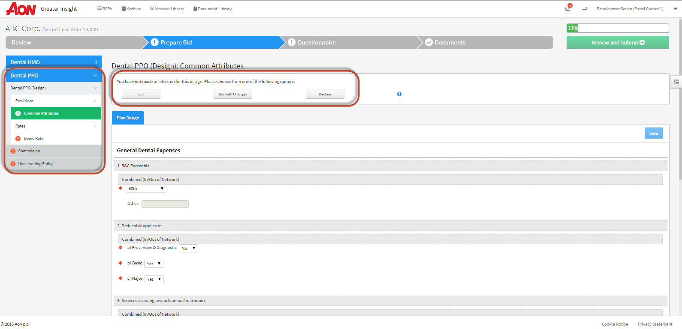

# Questionnaire(s)

In the event there are Questionnaires to complete for the RFP, you’ll see the link for the Questionnaire at the top of the page. All Questionnaires will be listed in this section. To open and respond to the Questionnaire, you’ll click on the Questionnaire name. Similar to the Design, Rates, and Additional Items section, the  changes towhen the section is complete.

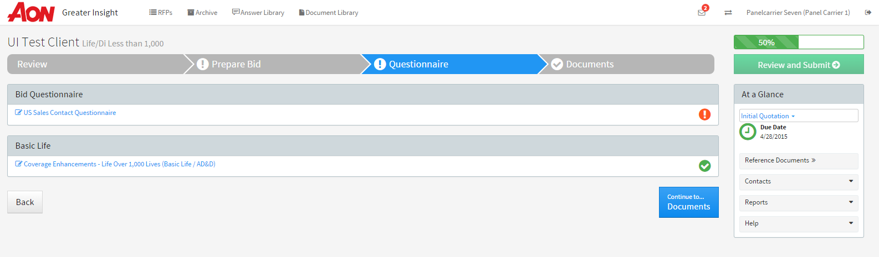

* Questions that need to be completed to submit your bid are identified with a red asterisk
* Questions that are recommended by not required are identified with a yellow asterisk

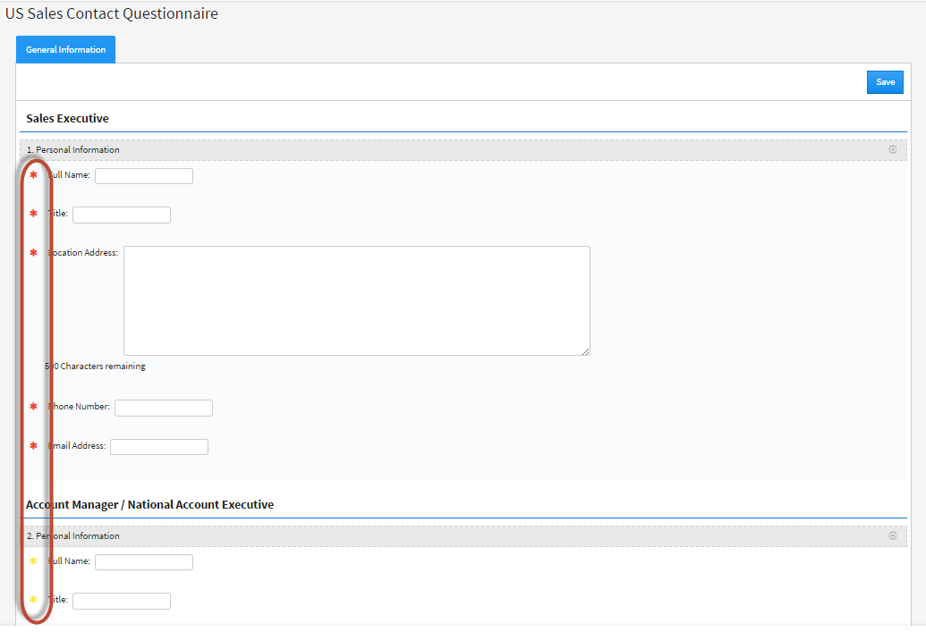

# Adding Documents

To add documents to the RFP, you’ll click on **Documents** at the top of the screen.

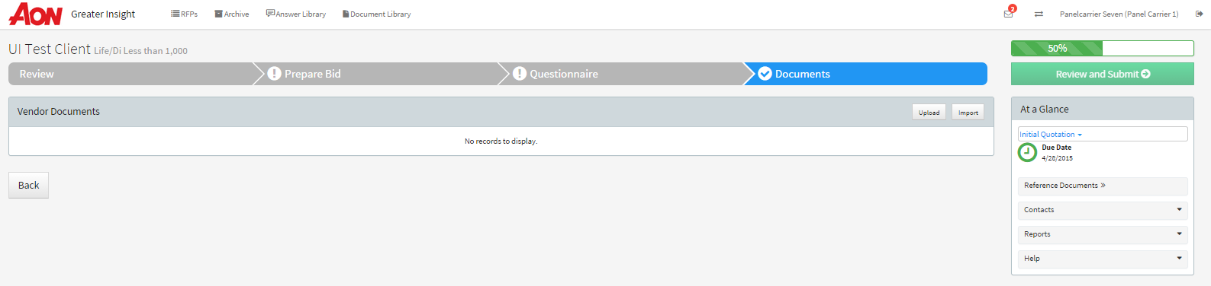

You can either **Upload** new documents to the RFP or **Import** documents from the Document Library section.

To add a new document to the RFP, you’ll click on **Upload** and then **Upload a File.** You can also drag and drop documents from your computer into the **Add a Document** page and they’ll automatically be added to the RFP.

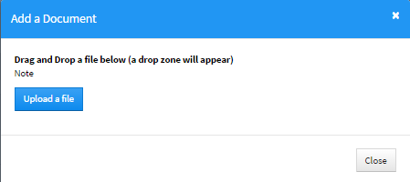

* **‘Documents’ may include these categories:**
  + **Documents** – This is the only location you will upload new documents or import documents from the Document Library as a part of your RFP response (details above).
  + **Reference Documents** **to Review**—your review is requested (located in Review section).
  + **Reference Documents**—documents are for your reference (located in At a Glance flyout).
  + **Required Documents**—documents requiring you to take action (located in Documents>Required Documents section).

Once you have completed all sections of the RFP you will see the **Review and Submit** icon is available. Click on the **Review and Submit** icon and you’ll follow a two-step process.

* Step 1:
  + Review your bid decision. Ensure the system reflects the appropriate plan design you intended to choose. If it says **Bid** then you are quoting on the design as is and do not intend to make any changes to it. If it says **Bid With Changes** then you are quoting but making changes to the design. If you’d like to review and/or make changes to your bid decision you can click on the Design name hyperlink.
  + Review the Total Annual Premium. This number should reflect the annual cost of the design. It will not represent any proposed designs (if you chose to propose a new design). The cost should only reflect the cost of the design we requested from you. If you need to adjust your Total Annual Cost you can click on the Design name.

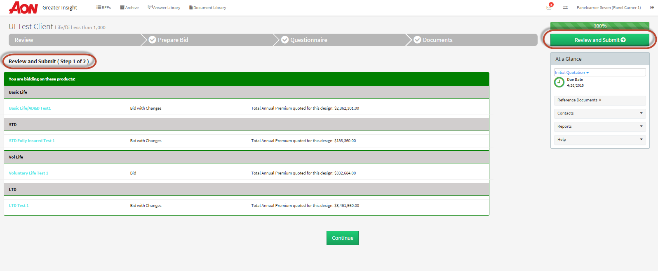

* Step 2:
  + Once you’ve reviewed your design decision and confirmed the accuracy of the financials you will click on **Continue** to officially submit your bid back to Aon. You’ll enter the date your Bid is valid through as well as confirm you have read the Terms and Conditions. Once you are ready to submit your bid you’ll click on the  button.

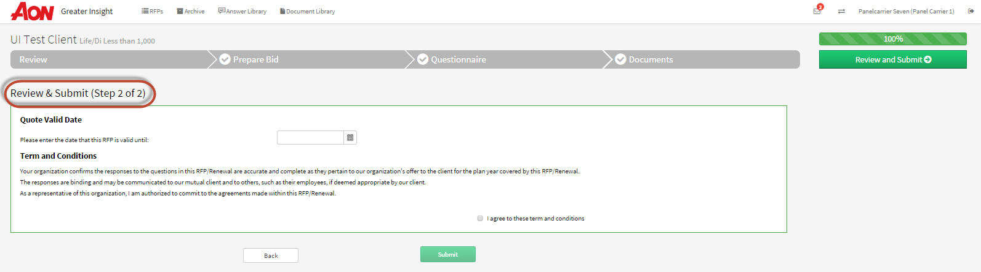

# Answer Library

The Answer Library can be used to store common responses to RFP questions and use those responses across multiple RFPs of the same type (e.g., stored responses for a Dental RFP questionnaire will display in Dental RFPs only).

* The Answer Library link is listed at the top of every page.
* The products your organization has access to are listed on the page. A set of responses can be stored by product which can be used to respond to an RFP by any contact at your organization with access to Greater Insight.
* Access the Answer Library and double click on the product to access the sections within it. Once the product is open you can identify if it is a questionnaire or a design by the type is listed under **Type.** To open it just click on its name.
* To set up a section in which to enter responses, double click on the Name of the section, select the New Version button, name the new version, e.g., V1, add Description, if desired, and save.
* To enter responses to the questions, double click the version name under Name in Response Versions.

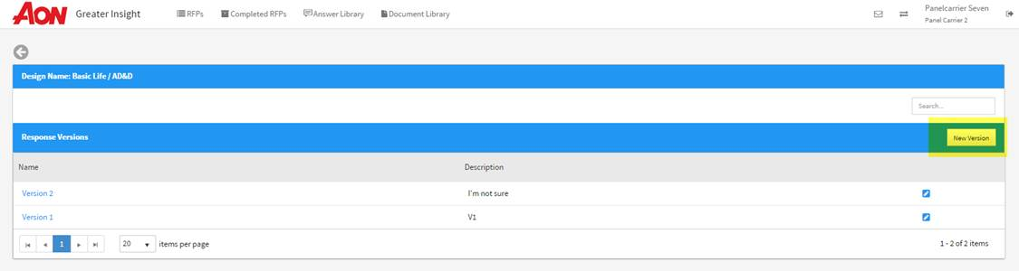

# Entering Information into the Answer Library

Once you have found the question in the Answer Library you will click on the icon at the bottom of the question. This step will allow you to enter a default answer (which will prepopulate the answer for you when responding to the RFP where you have chosen to Bid with Changes) or allow you to add multiple answers to choose from within the RFP.

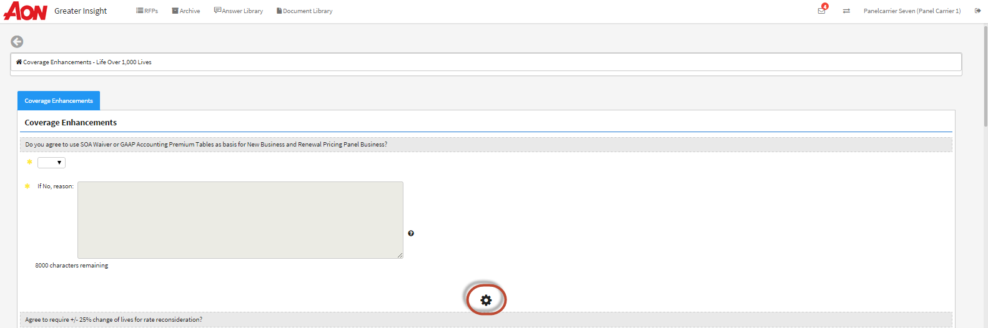

* **Default**: A response marked as ‘default’ will automatically be prepopulated as a response when responding to a client RFP and where user has chosen to Bid with Changes. You can setup more than 1 default answer for questions within the same product group.
* **Active**: A response marked as ‘active,’ will display a magnifying glass when responding to a client RFP to select the response from the list of stored active responses. You can use the plus sign in the upper right to save multiple ‘active’ responses for a question.

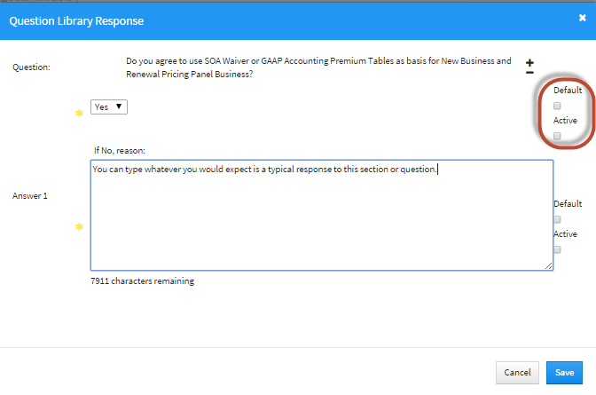

***Note:*** *When responding to a client RFP, a default response or active response can be updated within the RFP if the response is not accurate for that client RFP.*

# Document Library

The Document Library can be used to store important documents pertaining to the RFP process. These documents can be accessed and used across multiple RFPs of the same type (e.g., stored documents for a Dental RFP will display in Dental RFPs only).

* The Document Library link is listed at the top of every page.
* Documents can be sorted by name alphabetically or reverse alphabetically
* Documents can be found using the search field in the top right-hand corner
* Access documents within Document Library by double-clicking on the document hyperlink. The document will download to your computer.

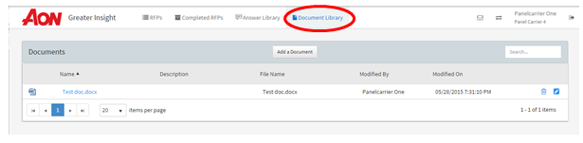

# Loading Documents into the Document Library

You can upload a document to the Document Library by selecting the “Add a Document” above the documents. Once the document has been uploaded, you can edit the document by choosing the pencil icon on the right side of the document line. Here you can update the name or description of the document as well as download the document file.

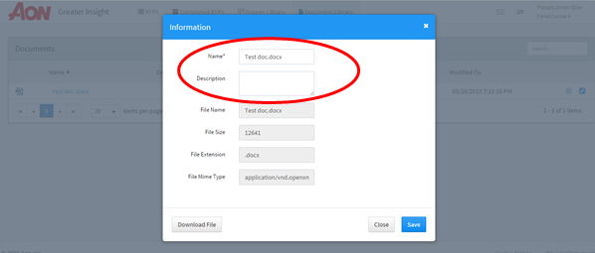

In order to delete a document, select the garbage can icon on the right side of the document line.

***Note:*** *After confirming to delete a document, the action cannot be undone. Be sure you have selected the exact document to be removed in order to prevent from deleting needed documents.*

# Aon Charter

* Aon is the world’s leading human resources and outsourcing firm. Our focus is to provide solutions that meet our clients' needs and we want clients to be confident that we have the expertise and experience to serve as a true partner, helping them with their most pressing risk, and people challenges.
* We have approximately 29,000 colleagues serving more than 20,000 clients, as one team, from offices in more than 120 countries. Supported by a formidable global footprint, deep talent, and rich resources, Aon’s team of professionals are dedicated to delivering distinctive value.
* We are the leaders in the U.S. market in the design, implementation, and support employee benefit programs and use both our size and standing to deliver the best value for our clients. Our integrated services put us in the unique position of enabling organizations of all sizes to optimize their benefits spend.
* We know that in order to deliver the best possible outcomes for our clients, we need to develop effective working relationships with providers, both at a U.S. and global level. Understanding your business, recognizing your value, add services, and being aware of your business strategy supports our ability to deliver employee benefits solutions to our clients.
* We believe that when working with clients and providers, we need to demonstrate innovation underpinned by an excellent, world-class approach. We want to develop our relationships with providers and clients to deliver **World Class Broking**. In order to do this, it is fundamental to understand the principals that we adhere to and the value this approach implies, to ensure we are achieving a common approach that will deliver value for all parties.
* As a global firm that is different by design, we are committed to delivering market innovation and solutions. This ensures we are best placed to recognize what our clients’ needs are today and in the future.

# Our Values, Our Strengths, and Our Commitments

* Our Size and Scale:
  + In the US, we place more than $12 Billion of health and welfare premium and premium equivalents often with providers who operate across more than one of our business lines. Our size and scale should ensure that we achieve the best possible pricing for our clients.
* Alignment of Your Strengths With Our Clients’ Needs:
  + Combining an understanding of your strengths and business objectives with our knowledge of clients’ requirements and priorities improves the advice we give them, and helps us identify the best match between their needs and your strengths. We will educate our staff about your strengths and new solutions in a consistent manner to ensure the best match with our clients’ needs.
* Strong Relationships With Providers:
  + Our clients benefit from having open relationships with their providers. Where appropriate, we will support the development of those relationships through product and industry events, such as, meeting with our Executive Board, Business Development Days with our consultants, Virtual Meetings with our staff for training events and attendance at Team Meetings.
* Enhanced Ability to Understand Risk and Client Requirements:
  + To support the delivery of valued based consultancy, Aon has built a platform with greater capability and global reach than any other firm in the market today. The platform is called Greater Insight. Through Greater Insight you benefit from consistent client submissions and will gain a more accurate understanding of clients’ risk profiles and requirements.
* Ability to Present Alternative Solutions For Consideration by Our Clients:
  + In addition to quoting on the requested basis, our online broking facility on Greater Insight means you will have the ability to offer alternative benefit design options for consideration by our clients. This ensures you get the best opportunity to present new services and solutions that our clients may value.
* Improving Efficiency and Client Service:
  + Aon is a market leader in driving efficiency and consistent with our drive to achieve operational excellence and superior client value we remain committed to our Client Promise. We expect our partner providers to support our client service mission by complying with our Service Level Requirements.
* Insightful Client Feedback:
  + Listening to our clients' needs drives our client focus and our exclusive tools—Aon Client Promise, and Greater—allow us to collect and analyze this feedback. This provides you with specific service evaluation directly from the business, our clients and from our consultants on behalf of our clients. Sharing this information with you at a local level will allow us to identify any service issues and address them.
  + Furthermore, through our broking tool on Greater Insight we will help you understand market changes providing information on:
    - The reasons why clients go to market
    - The reasons why clients choose certain providers
    - Market changes in plan designs and premiums
  + All of this can be broken down across locations, industry sectors and employee classes, as required. This will allow you to strategically forecast market trends, target certain markets in line with your strategy and understand industry developments.
* Open and Honest Dialogue About Value and Price:
  + By enhancing value for providers, we help you make your products and services more competitive, which will benefit our clients. We will add value to your business and we will be clear on how we charge for the services we provide.
* Global Reach:
  + A vast global network of colleagues and clients in 120 different countries provides huge opportunities for achieving scale and depth of understanding to providing client solutions.   
    Our global footprint and network enables us to deliver global solutions that meet local needs. Through data captured in Greater Insight, we can help carriers better understand the trends and specificities of local markets to design and deliver the most suitable solution to meet   
    client needs.

# Your Commitment

* The Best Value For Our Clients:
  + We expect you to price your products competitively and offer Aon distinct, market leading premium terms.
* The Best Coverage Terms and Conditions For Our Clients:
  + Our clients expect Aon to use our size and leverage to consistently secure the most competitive policy terms available.
* Excellent Administration Support and Flexibility:
  + Our clients demand effective administration support and service. We expect all such services to be provided by a dedicated, high performing team who treat us as priority.
  + We need to understand your plans so that we can work with you to deliver significant improvements for clients.
  + We also want clear lines of accountability and communication so we can address any service related issues when required.
* Listening to Our Clients’ “Feedback:”
  + We will provide you with specific service evaluation directly from the business, our clients and from our consultants on behalf of our clients. Understanding how you will use this feedback will allow us to inform our clients and therefore monitor service enhancements.
* New Products:
  + Our clients need innovative solutions to deal with the changing risks and employee benefits issues they face. We want to have the opportunity to develop such solutions with you so that we get the first opportunity to present these to our clients and ensure they have a meaningful impact.
* Constructive Dialogue at All Levels:
  + We expect you to engage in constructive dialogue and to accept that when we escalate issues, we do it for the good of our clients.
* Transparency and Compliance:
  + Integrity is a key value on which we pride ourselves. We expect you to be just as accountable as we are in adhering to all transparency, disclosure and regulatory requirements when we do business together.
* Open Relationships and a Level Playing Field:
  + We need to be confident that you value relationships with us, that you are prepared to develop relationships at all levels and that you are committed to the intermediated market. We expect to be treated fairly and given at least the same opportunities, you would offer any benefits consulting firm/broker to service our clients.
* Fair Compensation For The Value we Create:
  + We firmly believe that we create more value than any other benefits consulting firm/broker, and we expect to be compensated accordingly.

Thank you for being a valued business partner.