Matlacha Pass Hydrologic Restoration Project
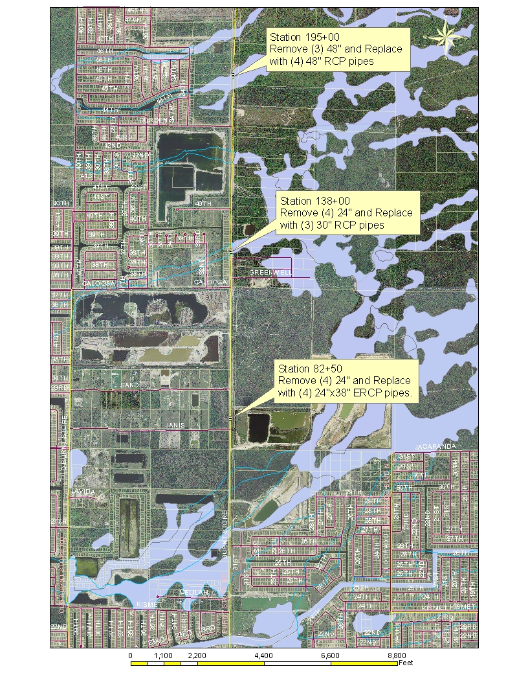
Project Objective:
Project extends from Kismet Parkway in Cape Coral, FL northerly along Burnt Store Road to a point 1700 feet north of Durden Parkway, Cape Coral, FL. The purpose of this project is to restore historical flow patterns in northwest Lee County drainage basin which currently drains into Matlacha pass across Burnt Store and Old Burnt Store Road. This project will reduce interbasin transfer of stormwater runoff that is occurring in the existing condition and reduce diversion of stormwater south to Gator Slough caused by Burnt Store Road and Old Burnt Store Road.

The project will involve expansion of three (3) cross-drain culverts under Burnt Store Road located a STA 82+50, 138+00 and 195+00 to improve east to west flow pattern. Roadside ditches along Burnt Store road and the side-drain improvements along with two (2) drop structures north of Gator Slough Bridge at Burnt Store Road, STA 11+00, are included.

Expected Completion Date: December, 2008

Project Budget: $1,200,000

Project Status: Permits in place. Plans and specifications at 100%.
Prequalification of Contractors has commenced.

Contact information:
Anura Karuna-Muni. P.E., Ph: 239-533-8131
e-mail: AKaruna-Muni@leegov.com
or
Tildon Copeland, Staff Engineer Ph: 239-533-8139
e-mail: TCopeland@leegov.com

