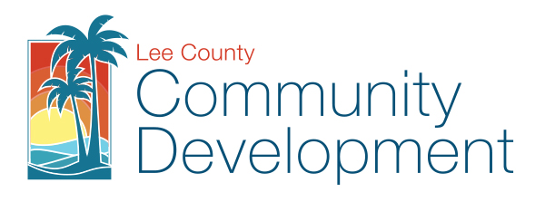
HISTORIC PRESERVATION PROGRAM

CERTIFICATE TO DIG APPLICATION
Lee County Planning Division, PO Box 398, Fort Myers, FL 33902
Phone: (239) 533-8585 / FAX: (239) 485-8344

If the applicant has registered for ePlan, this application can be submitted electronically by emailing it to ePlan@leegov.com. Once the applicant receives the project invite the additional documents with the file names of Arial.pdf and Site Plan.pdf should be uploaded to the submittal documents folder of the project. ePlan Users read the second page of this application for further directions.

Date: |  |  |  |  |  |  |  |  |  |  |  |  |  |  |  |  |  |  |  |  |  |  |  |  |  | FDO #:
NOTE: It is the applicant’s responsibility to obtain ALL required permits and approvals – including Building Permits – prior to project initiation. This Certificate to Dig can in no way be construed as a Building Permit.
Name of Project:
Location:
STRAP No.:
Name of Applicant or Agent*:
(*All correspondence with regards to the Certificate to Dig will be sent to the party identified above)
 | Address:
 | City, State, Zip:
 | Phone Number: |  |  |  |  |  |  |  |  |  |  |  |  |  |  |  |  |  |  |  |  |  | Fax Number:
 | Agent Email Address:
 |  |  |  |  |  |  |  |  |  |  |  |  | (If applicable, this is the email address that will received the ePlan invitation)
Activity:
NOTE: Aerial and site plans must be included with application.
FOR STAFF USE ONLY

APPROVED: |  |  |  |  |  |  |  |  |  |  | Conditions:
Certified by: |  |  |  |  |  |  |  |  |  |  |  |  |  |  |  |  |  |  |  |  |  |  |  |  |  |  |  |  |  | Date:
DENIED: |  |  |  |  |  |  |  |  |  |  | Reason:
Level 1 |  |  |  |  |  |  |  |  |  |  |  | Level 2 |  |  |  |  |  |  | None |  |  |  |  | FMSF #:
Condition: |  |  |  |  |  |  |  | Unaltered |  |  |  |  |  |  |  |  | Disturbed |  |  |  |  | Destroyed
Actions (check all that apply): |  |  |  |  |  |  |  |  |  |  |  |  | Survey |  |  |  |  | Salvage |  |  | Test Pit |  |  |  | Full Excavation |  |  |  |  |  |  | Designation | None
Comments:

LEE COUNTY
CERTIFICATE TO DIG
APPLICATION

NOTE: A Certificate to Dig is required prior to or in conjunction with the issuance of a final development order for activity within any area of Archaeological Sensitivity Levels 1 or 2 (as identified in the survey known as "An Archaeological Site Inventory and Management Plan for Lee County, Florida"). "Activity" is defined in the Lee County Land Development Code, Chapter 22, Article II, Div. 3, Sec. 22-106(c)(1), as "new construction, filling, digging, removal of trees, or any other activity that may alter or reveal an interred archaeological site."

The purpose of the Certificate to Dig is to allow sufficient time to conduct any investigations including the location, evaluation and protection of significant archaeological sites in areas suspected of having such sites.

The Certificate to Dig may be issued with conditions that may involve the further excavation or study of the subject site. All work performed pursuant to the Certificate to Dig shall conform to the requirements of the certificate. In the event of noncompliance, the county shall have the power to issue a stop work order and all work shall cease.

Aerial and site plan must be included with the application and submitted to the Lee County Planning Division.

Notes regarding applications submitted through ePlan:

If the applicant would like to submit additional documents other than a Site Plan and an Arial, the files should be named according to what they are. (i.e. – ‘Survey.pdf’ or ‘Cover Letter.pdf’).

Review the Lee County ePlan Users Guide for directions relevant to all ePlan Applicants.

