Lee County Domestic Animal Services
Registration Form
Painting Party Fundraiser Sunday, August 26, 2018, 3:00 – 6:00 p.m.
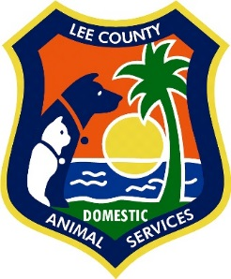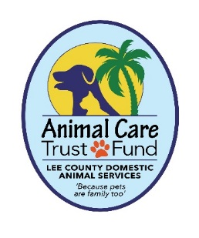
Location: Lee County Domestic Animal Services Shelter
5600 Banner Drive Fort Myers, Fl 33912

NAME: ______________________________________________
EMAIL: ______________________________________________
PHONE: _____________________________________________
PAINTING OPTION: Puppy-n-Kitty Fun __
Out for a Walk __
Checks payable to Lynda Coon. Registration deadline August 8, 2018

Registration form and $40.00 payment (check only) can be mailed to:
Melissa Coon
P.O. Box 398
Fort Myers, FL 33902-0398
Out for Walk Puppy-n-Kitty Fun
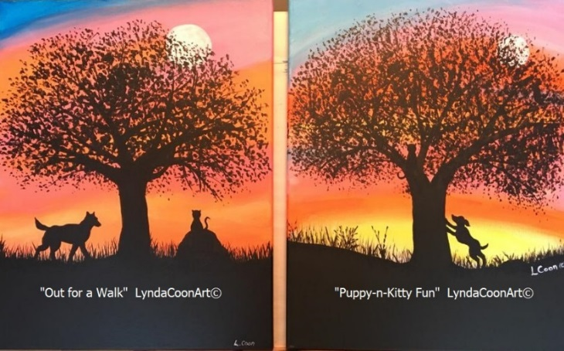
Questions? Contact Melissa Coon at mcoon@leegov.com

