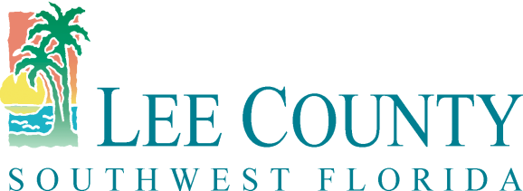
Procurement Management Department
1500 Monroe Street 4th Floor
Fort Myers, FL 33901
Main Line: (239) 533-8881
Fax Line: (239) 485-8383
www.leegov.com/procurement

PUBLIC MEETING NOTICE

Posted Date: February 16, 2018

Solicitation No.: RFP170475GWT

Solicitation Name: Real Estate Appraisal Services County Wide and/or Conservation 20/20 Lands Program

Subject: Evaluation Meeting

To: All Interested Proposers and to the General Public

The Evaluation Committee will meet to evaluate the proposals received for the above solicitation.

Date of Meeting: | Tuesday, February 20, 2018
Time of Meeting: | 1:00 PM
Location Name: | Lee County Public Works Building
Address: | 1500 Monroe St, 4th Floor, Room 4A
City/State/Zip | Fort Myers, FL 33901

The Evaluation Committee will discuss, score and rank each proposal received. The discussion/evaluation phase of the meeting is open to the public. Public comments are limited to 3 minutes per person.

Note: If there is a tie, (two or more firms have the same number of 1st place rankings) please refer to the solicitation documents for the method to determine the “Tiebreaker”.

Thank you for your interest in Lee County Projects. If assistance is needed, please call Lee County Procurement Management.

Sincerely,
LEE COUNTY PROCUREMENT MANAGEMENT

Geoff Thomas
Procurement Analyst

