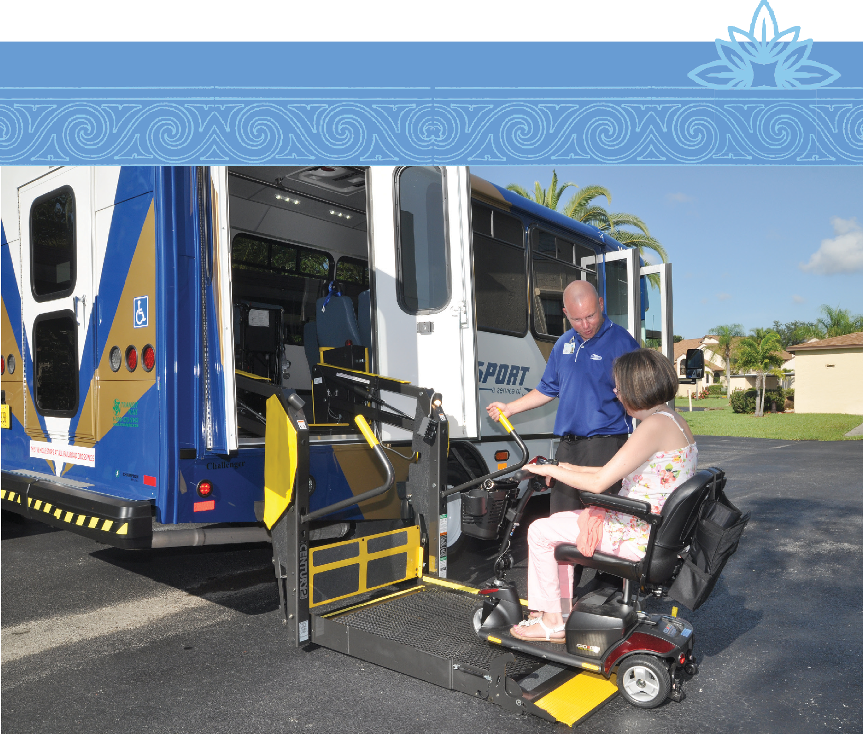

1

PASSENGER’S GUIDE

Introduction to Passport ADA Service
ADA stands for Americans with Disabilities Act. Lee County Transit’s ADA paratransit service, called Passport, is offered in strict accordance with the ADA Act of 1990. The ADA service is for persons with physical, cognitive, visual and/or other disabilities which functionally prevent them from using the LeeTran fixed route bus system either permanently or under certain conditions.

How Do I Become Eligible?
Disability alone does not confer or create eligibility for ADA paratransit. The decision is based solely on the applicant’s functional ability to use the fixed route buses. Instances where using the fixed route buses are viewed as inconvenient or an additional discomfort are not reasons for eligibility. Your disability must actually prevent you from using the fixed route buses. Eligibility for service is a transportation decision, not a medical determination.

To be eligible for service, a disability must prevent the use of the LeeTran buses, and the origin and destination of your trip must be within 3/4 of a mile of a fixed route. Origins or destinations outside of this service area are not eligible. Both of these requirements must be met before you are eligible for an ADA trip. You will be required to participate in an in-person, face-to-face assessment in order to determine your eligibility and discuss the program.

There are three categories under which a person can be eligible for ADA paratransit service:

- Category 1
Eligibility includes those persons, who, because of their disability,
cannot independently use a regular, accessible bus.

- Category 2
Eligibility is based on the accessibility of vehicles and terminals/stops
(i.e., a person is able to use the regular bus, but it is not accessible).

- Category 3
Eligibility pertains to situations in which a person cannot travel
independently to or from a bus stop.

A person can be given “conditional” eligibility for ADA paratransit service if they are able to use the bus under certain conditions, but not others; in those situations, eligibility will be determined according to a particular set of circumstances or conditions which pertain to a person’s disability.

If you are approved for ADA paratransit transportation, you will receive a Certificate of Eligibility ID Card and a letter outlining how to use the services. You will receive door - to- door transporta- tion.

Lee County sponsors the cost of the trip, and your transportation will cost you a $3.00 fare every time you board the vehicle. You must pay the exact $3.00 fare to the driver at the time of service, or you may be refused transportation. Drivers do not make change.

All of the vehicles sent to pick you up are ADA accessible. They will have lifts or ramps to assist passengers in boarding and loading wheelchairs. All of the drivers are trained in assisting passengers with disabilities.

If I’m denied, how do I appeal?
If you choose to appeal the decision, you must make a written request within sixty (60) days of the decision
and send to the address below.

LeeTran
C/O ADA Appeals 3401 Metro Parkway Ft Myers, FL 33901

You will be contacted to schedule the hearing. If necessary, transportation can be provided to the hearing
at no cost to you.

What types of transportation are NOT included in LeeTran’s ADA service?
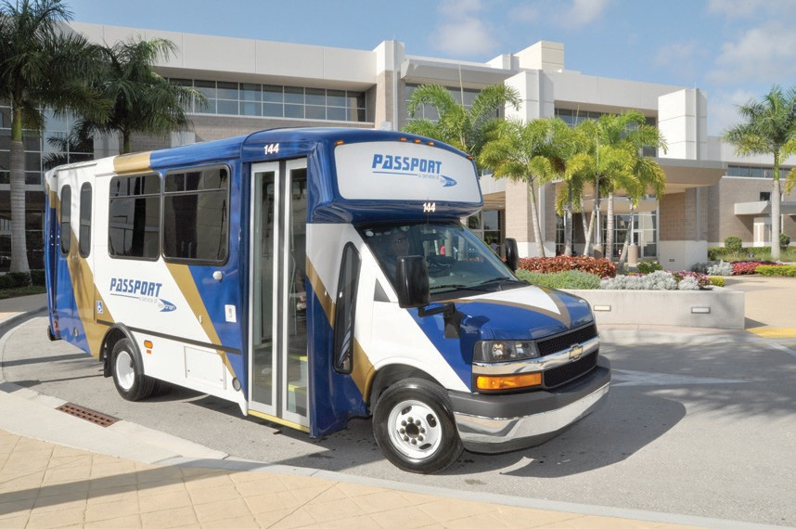
LeeTran is not the Medicaid Transportation Provider. Medicaid clients may receive their Medicaid transportation through Good Wheels or a local Florida Managed Medical Assistance Provider (MMA), depending on Medicaid program criteria. Good Wheels is a Medicaid Provider in Lee County as well as the designated Community Transportation Coordinator (CTC), under Florida Statue
F.S. 427, for Lee County. Medicaid clients must call the Medicaid Enrollment Help Line for information regarding MMA enrollment, benefits, and Medicaid medical transportation at 1-800-226-6735.

LeeTran is not the CTC for Lee County, and therefore is not responsible for the Transportation Disadvantaged non-sponsored transportation program. This is a state program administered and sponsored through the Florida State Commission for the Transportation Disadvantaged (CTD), under F.S. 427, Transportation Disadvantaged Service. Good Wheels, Inc. is the CTC and provider for this service.

Please contact Good Wheels for information and enrollment. Under this program, trips are provided throughout Lee County with significantly less stringent enrollment requirements than the federal ADA eligibility. Social service agencies are also required to receive service and coordinate through Good Wheels. To contact Good Wheels, please call 1-800-741-1570 or 239-768-2900. To contact the Florida Commission for the Transportation Disadvantaged, please call 1-800-983-2435. It is strongly recommended that applicants call Good Wheels first before proceeding with the ADA application.

LeeTran is prohibited by federal regulations from providing school transportation to schools or school- related activities.

LeeTran is also prohibited from providing charter or private group services.

For additional information and to begin the application process, please call the LeeTran Passport office at 239-533-0300 between the hours of 8:00 a.m. and 5:00 p.m. Monday through Friday.

Schedule of Operations
ADA Passport service is available during the same days and hours as LeeTran’s fixed route service. In general, buses operate Monday through Saturday from 5:00 a.m. to 10:00 p.m. A limited number of routes offer Sunday service. Please check the individual route schedule that corresponds to your planned trip for exact hours of operation. This information is available at www.rideleetran.com.

Passport service is closed on six major holidays: New Year’s Day, Memorial Day, Fourth of July, Labor Day, Thanksgiving, and Christmas. Fixed route service is also closed on these holidays. Please confirm service availability when you call.

Reservations
Eligible riders may schedule a trip on the LeeTran Passport service by calling the Passport Office at 239- 533-0300, Monday through Friday, 8:00 a.m. until 5:00 p.m. For weekend service, and/or holidays, please follow voicemail instructions.

Passengers approved for Passport service are required to book their reservation at least the day before the requested trip, but cannot book a reservation more than two weeks in advance. It is permissible under ADA regulations for reservations staff to negotiate the requested pick- up time within a one-hour window before or after the passenger’s requested pick-up time. Vehicle pick-up time is based on appointment time and vehicle travel time.

When you call to schedule a trip, please be ready to provide:

- Your name and date of trip
- The time you want to be at your appointment and your return trip pick-up time
- Your pick-up address and telephone number
- Destination name, address, suite number and telephone number (due to the volume of
reservations, our agents are not able to research address information)
- Whether you use a wheelchair or other mobility device
- When a personal care attendant (as indicated during the eligibility process) or guest will be riding with you, along with their name(s).
- The specific door, entrance or waiting area at which
you wish to be picked up and dropped off

Visitors
Visitors who are eligible for ADA service in other cities and have documentation may use the Passport service during their visit to Lee County. Visitors who do not have documentation of ADA eligibility from another transit agency, but can provide documentation of a disability, may be eligible to use the service for up to twenty-one (21) days.

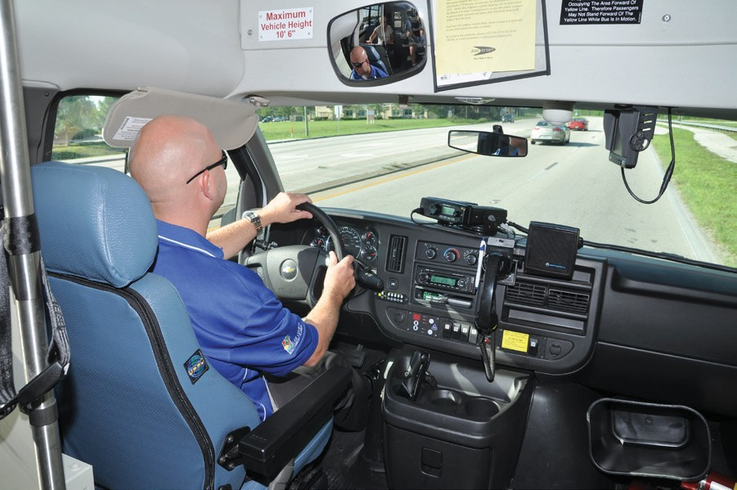
Boarding and Riding

LeeTran is a shared ride system, and other individuals may need to be scheduled on the same vehicle. It may be necessary to get to an appointment a little early or picked up from a return a little later than requested. LeeTran will make every effort to offer a pick up and drop off time that is as close as possible to the times requested. Passengers are required to be ready up to one (1) hour before their drop-off (appointment) time. For longer, cross-county trips, you may be required to be ready up to 90 minutes before. The driver may arrive within thirty (30) minutes (Pick up Window) after your scheduled pick up time. Passengers may be dropped off up to
thirty (30) minutes prior to their requested drop off (appointment) time. For the return trip, the driver may arrive up to thirty (30) minutes after your requested return pick-up time (Pick Up Window).

Passport is door-to-door transportation. Drivers are not permitted to lose sight of their vehicle or leave their vehicle unattended with passengers on board longer than 15 minutes. If a passenger lives in an apartment building, adult care living facility, nursing home, or similar place that has a common lobby, the passenger is required to meet the driver in the lobby. The passengers are to be fully dressed and ready to board the vehicle. Drivers are not allowed to assist passengers in dressing. Drivers are not allowed to lift, carry or load passengers into their mobility devices (i.e., wheelchair , scooter, etc.). Passengers may board the vehicle either via lift, ramp or doorway. Drivers will assist riders when entering and leaving the vehicle. This includes offering a steady arm when walking, assisting in bringing the rider’s wheelchair or other mobility device to and from the main door, or if requested, assisting with unlocking and/or opening a main entrance door of the building or residence. Drivers are not allowed to enter residences or take wheelchairs up or down more than one step.

For safety, passengers are to wait for the drivers instructions before exiting the vehicle. Passengers are not
to unfasten their mobility devices or move their mobility devices without prior instructions from the driver.

If the destination is in an office complex, hospital, or has a common lobby, drivers will leave the passenger
in the lobby. The following are the standard entrances for main destinations.

Standard Entrances
Bell Tower Shops Bed, Bath & Beyond, Regal Cinemas and Fresh Market Cape Coral Hospital ER, Women’s &Children’s Entrance or Main Entrance Edison College Parking Lots 2 and 5, & Barbara B Mann Hall
Edison Mall Valet Entrance and Entrance G
Fleamasters Flea Market Customers Service building @Main Entrance, Gate 1 and Gate 8
Florida Gulf Coast University Transit Bus Stop and Alico Arena
Gulf Coast Hospital Front Main Entrance or ER, & Birthing Suites Gulf Coast Medical Bldg. Main Lobby facing Hospital
HealthPark Hospital Entrance B, Emergency Room and Loading Dock HealthPark Medical Bldg. Main Lobby
Lee Memorial Hospital Main Entrance or ER
Lee Memorial Doctors Bldg. Lobby by Valet Parking
Miromar Mall Ford’s Garage and Bloomingdales
Target Food Entrances
Walmart Food Entrances

Being On Time
Passport vehicles are required to announce themselves and wait for the passengers five (5) minutes after their arrival time. If an individual has not boarded the vehicle within five (5) minutes after the vehicle arrives, the driver will contact dispatch to request permission to mark the trip a no-show. If the trip is beginning at the residence, dispatch will make an attempt to call the passenger. Once approved by dispatch, the driver will leave a No Show Door Hanger Notice then the vehicle will depart and a “no show” will be assessed to the passenger’s record. If the trip is the originating trip of the day (first trip of the day), a vehicle will not be sent back. Exceptions are made if there was an error in scheduling or the driver was at the wrong location. See No Show section for more information.

Transporting Packages, Oxygen, Etc.
Passengers are to limit their packages to four (4) small parcels that they can carry. Drivers are not allowed to assist riders with personal belongings. If you have difficulty handling your packages, please bring a personal care attendant or guest to assist you. Under limited circumstances the passenger may request the driver to assist with their belongings. However, the driver must be able assist the passenger and carry the items in one trip. Personal, two-wheeled, collapsible grocery carts are permitted and encouraged.
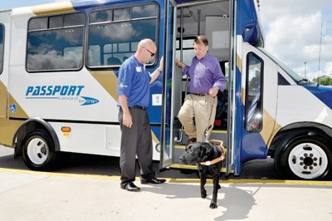
Large coolers are not permitted. Small animals in designed pet travel cases are permitted, as long as the passenger is able to carry the pet travel case. Any packages or objects belonging to passengers cannot block aisles or emergency exits. It is important to remember that Passport is a shared-ride system. Passengers may not transport potentially dangerous items, explosives, flammable liquids or materials that are hazardous to themselves, drivers or other passengers. Passengers
possessing or using illegal drugs may be denied or terminated from transportation. Passengers using self-carrying portable oxygen are granted transportation, as it is a life-sustaining mobility aid.

Service Animals
A service animal is defined as an animal trained to work or perform tasks for an individual with a disability. Service animals may ride at no additional charge, but must be properly controlled. Service animals must remain at the owner’s feet or on the owner’s lap. A service
animal cannot sit on a vehicle seat or obstruct aisles, doors and steps in order to facilitate safe boarding. Passengers are responsible for the behavior and hygiene needs of the service animal. Service can be refused or discontinued if a service animal is seriously disruptive or violent.

Wheelchairs, Scooters and other Mobility Devices
LeeTran vehicles are designed to accommodate wheelchairs and other mobility devices. As long as the passenger is able to safely navigate the manual or motorized mobility aid on and off of the ramp or lift without exceeding the manufacturer’s maximum weight limit, LeeTran can transport the device. Passengers that are able to, may board separately than their device in instances where the weight limit may be exceeded. If your wheelchair or mobility device exceeds the size that can be accommodated on a wheelchair lift or ramp or cannot fit within the securement area in the vehicle, transportation with LeeTran service may be denied until you are able to obtain a mobility device that meets these criteria.

Wheelchair Securement and Seat Belt Policy
It is the driver’s responsibility to ensure that mobility devices are properly secured. All wheelchairs and scooters must be secured in the vehicle’s four point securement system at all times during the ride. All individuals are required to comply with Florida’s seatbelt law.

Cancelled Trips
It is very important that you call well in advance, and no later than two (2) hours before the trip if you find it necessary to cancel. This will prevent a vehicle from being assigned to pick you up. Trips cancelled with less than two (2) hours notice will be considered a LATE CANCELLATION and will be counted as a No Show.

LeeTran Passport service reserves the right to deny service for a reasonable length of time to riders that show a pattern or practice of Late Cancellations. For additional information, please contact the Passport office.

LeeTran Passport No Show Policy
A No Show is defined as:

  - Late Cancellations (less than 2 hours notice) are considered
a No Show

  - When a driver arrives within the prescribed pick up time and the passenger does not go, or fails to respond within five (5) minutes of the vehicles arrival time is considered a No Show.

Frequency of trips along with the number of missed trips will be used to determine a no show percentage rate. This no show percentage rate will be compared to the Passport
system-wide no show rate to identify a pattern of excessive no shows.

At the end of the month, those passengers who have been recorded as having (3) or more No-Shows will be reviewed to identify the passenger’s trip and No-show history as well as their frequency of travel. Each No-show will be verified to determine circumstances of the missed trip.

Those passengers whose No-Show rate is more than 5 (five) percent and in excess of the average No-Show rate for the month may be subject to disciplinary action up to suspension of services if the No-shows are determined to constitute a pattern. Excused occurrences are not part of the calculation.

The formula for determining the average No-Show rate is:

No-Shows / Total trips per month = Average No-Show rate for the month

Passengers should always make every effort to cancel trips that are no longer needed. Circumstances that occur for reason beyond the control of the passengers that result in a late cancellation / no-show will not be counted against their missed trips.

Under Federal Transit Administration guidelines, LeeTran Passport Service reserves the right to deny service for a reasonable length of time to riders who show a pattern or practice of no shows. These riders are notified in writing. If this misuse of service continues, loss of transportation privileges may be imposed.

Fares
Passengers are required to pay a fare for Passport transportation before they can ride. The current fare is $3.00 per trip. The fare is subject to change. The fare charged to an ADA eligible user shall not be more than twice the fare that would be charged to an individual paying full fare (without regard to discounts) for a trip of similar length, at a similar time of day, on Lee County Transit’s fixed route system. In calculating the full fare that would be paid by an individual on the fixed route system, LeeTran may include transfer and premium charges applicable to a trip of similar length, at a similar time of day on the fixed route system. ADA regulations 49 CFR, Part 37, Section 37.131 allow transit agencies to charge a higher fare to a social service or other organization for agency trips.

The fares for any passengers accompanying ADA eligible individuals shall be the same as for the ADA eligible individuals they are accompanying, with the exception of Personal Care Attendants. Passport passengers may take Personal Care Attendants (PCA’s) with them. A PCA is defined as an individual who is medically necessary to aid an ADA passenger. A Passport passenger must be pre-approved to take a PCA. PCA’s do not have to pay a fare to ride Passport.

Passport passengers may also bring guests with them. Guests must pay the regular Passport fare to ride. A guest can be anyone who wishes to ride with the passenger.

When booking a trip, each passenger must tell the reservationist if a PCA or a guest will be accompanying him or her. At the time the reservation is made, the passenger must provide the number of people traveling with him/her, and if they will have any mobility aids (i.e., wheelchair, walker, oxygen, etc.) with them on their trip.

Passport tickets may be purchased in advance by calling 533-0300, by mail, or by visiting the Passport office between the hours of 8 a.m. and 4 p.m..

Subscription Service
A subscription trip is a trip that is regularly repeated between the same origin and destination and at the same times.

Passengers that utilize Subscription Service must call in and cancel their trips when taking vacation or when other circumstances cause the passenger to not need the trip. If the passenger No-Shows a Subscription Trip more than three (3) subsequent trips in a row, the Standing order will be cancelled until the passenger calls to confirm that they still need a Subscription Trip.

Subscription service is not a requirement of the ADA. ADA regulations 49 CFR, Part 37, Section 37.133 permit transit agencies to establish waiting lists or other capacity controls and trip purpose restrictions (e.g., work trips only) or priorities for participation in the subscription service. Subscription service may not absorb more than fifty (50) percent of the number of trips available at a given time of day, unless there is non-subscription capacity.

Rules of Behavior
- Pursuant to the Florida Clean Air Act (F.S. 386), smoking in public vehicles is strictly prohibited. ADA transportation is a shared-ride system, in which people with various disabilities ride with other passengers. Some passengers may require oxygen, while others may be medically fragile. Smoking is therefore prohibited on all ADA Passport vehicles. If such an occurrence happens, a hearing with the ADA Disciplinary Committee may be scheduled.

- Exact fare must be paid when boarding. Drivers do not make change.

- Eating and drinking are prohibited in all Lee County Passport
vehicles (unless medically needed).

- No littering in the vehicles.

- No radios, MP3 players or CD players, or sound-generating equipment are to be played aloud
aboard the vehicle. Riders must use earphones or headphones when using these types of devices.

- All passengers are required to wear seatbelts including shoulder belts for wheelchair clients, while
being transported in Lee County Passport vehicles.

- Unscheduled stops are not allowed (i.e., stopping at convenience stores for drinks, stopping at pharmacies for prescriptions, etc.). Drivers are only allowed to make stops at destinations listed on
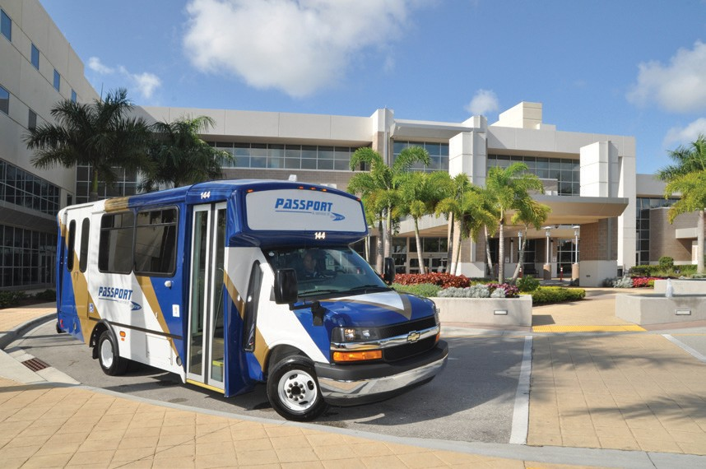
their manifests.

- Passport cannot make same-day changes to reservations.

- Violent, disruptive or illegal behavior will not
be tolerated. Passengers who are physically or verbally abusive to drivers or other passengers, or are otherwise disruptive, will be subject to disciplinary actions which may lead to suspension of service. If necessary, LeeTran staff will contact the appropriate law enforcement authorities to have a disruptive individual removed
from the vehicle. ADA regulations 49 CFR, Part 37, Section 37.5(h) allow transit agencies to refuse service to an individual that engages in violent, seriously disruptive or illegal activity.

- Due to safety concerns, Passport may modify the exact pick-up
or drop-off location.

Disciplinary Committee
On occasion, when there are transportation or passenger problems, a disciplinary committee will meet to review such matters. The disciplinary committee consists of representatives of Lee County Transit, Lee County’s Office of Equal Opportunity, and two passengers of Passport transportation. The disciplinary committee meets on a case-by-case basis, but may meet monthly if the need demands that it does so.

Premium Service
Premium Service is designed to allow ADA eligible passengers to travel outside of the ADA ¾ mile service area and extended hours and service days outside of the regular Fixed Route Schedules. Premium reservations are only allowed to be booked two days in advance. Trips are limited and on a first come, first serve basis. Premium Fare: $6
Premium Hours of Service: 5am to 10pm
Premium Service Days: 7 days a week
Please Contact Reservations for more information.

ADA Complaints, Service Related Complaints or Suggestions
All complaints should be reported to Lee County Transit (LeeTran). Please be specific and give relevant details regarding the trip. Share concerns about specific rides or incidents as soon after the actual occurrence as possible. Every complaint will be investigated.

For any complaint received directly by Passport Staff, the complaint follow-up shall be handled in the following manner:

All complaints received will be entered in to the Complaint / Request for Action database. All complaints received either by phone, mail, e-mail, and fax or in person will be entered in to the Complaint / Request for Action database to initiate an investigation into the complaint. Written and faxed complaints will be scanned and attached to the electronic complaint file. For any written complaint or voice mail complaint received, a verbal acknowledgment will be made within twenty-four (24) hours to the customer to inform the person that their complaint is being investigated. Within five (5) working days a follow-up letter will be sent to the individual filing the complaint to give the resolution to the complaint and determine if the problem has been resolved to the person’s satisfaction. At the discretion of the Operations Manager, and depending on the severity of the complaint a verbal response may replace the written response and this will be documented in the complaint file.

Contact us at:
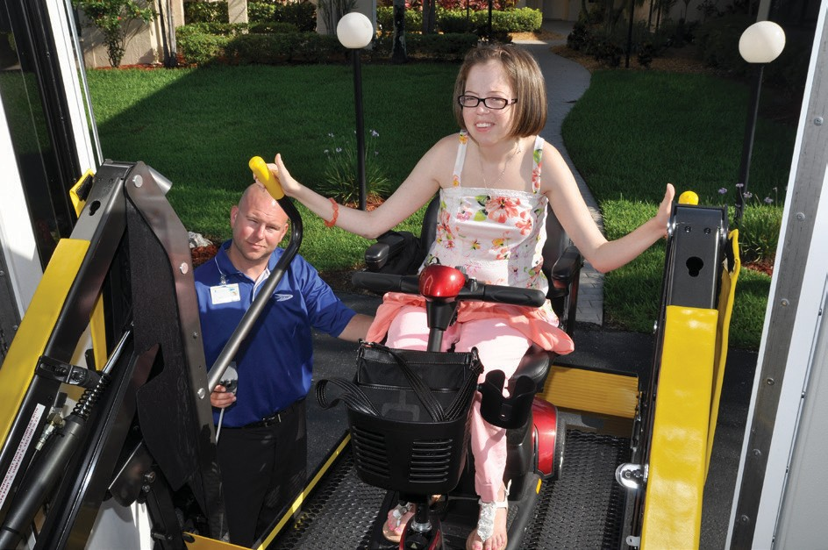
Passport, a service of LeeTran
3401 Metro Parkway Fort Myers, FL 33901

Reasonable Modification
Requests for modifications of LeeTran’s policies, practices, or procedures to accommodate an individual with a disability, may be made either in advance or at the time of the transportation service. LeeTran is best able to address and accommodate a request when customers make their requests for modifications in advance.
Requests may be made through the following means:
• Call (239) 533-0300 ext 30354.
- Passport customers may make requests at the time of booking their trips.

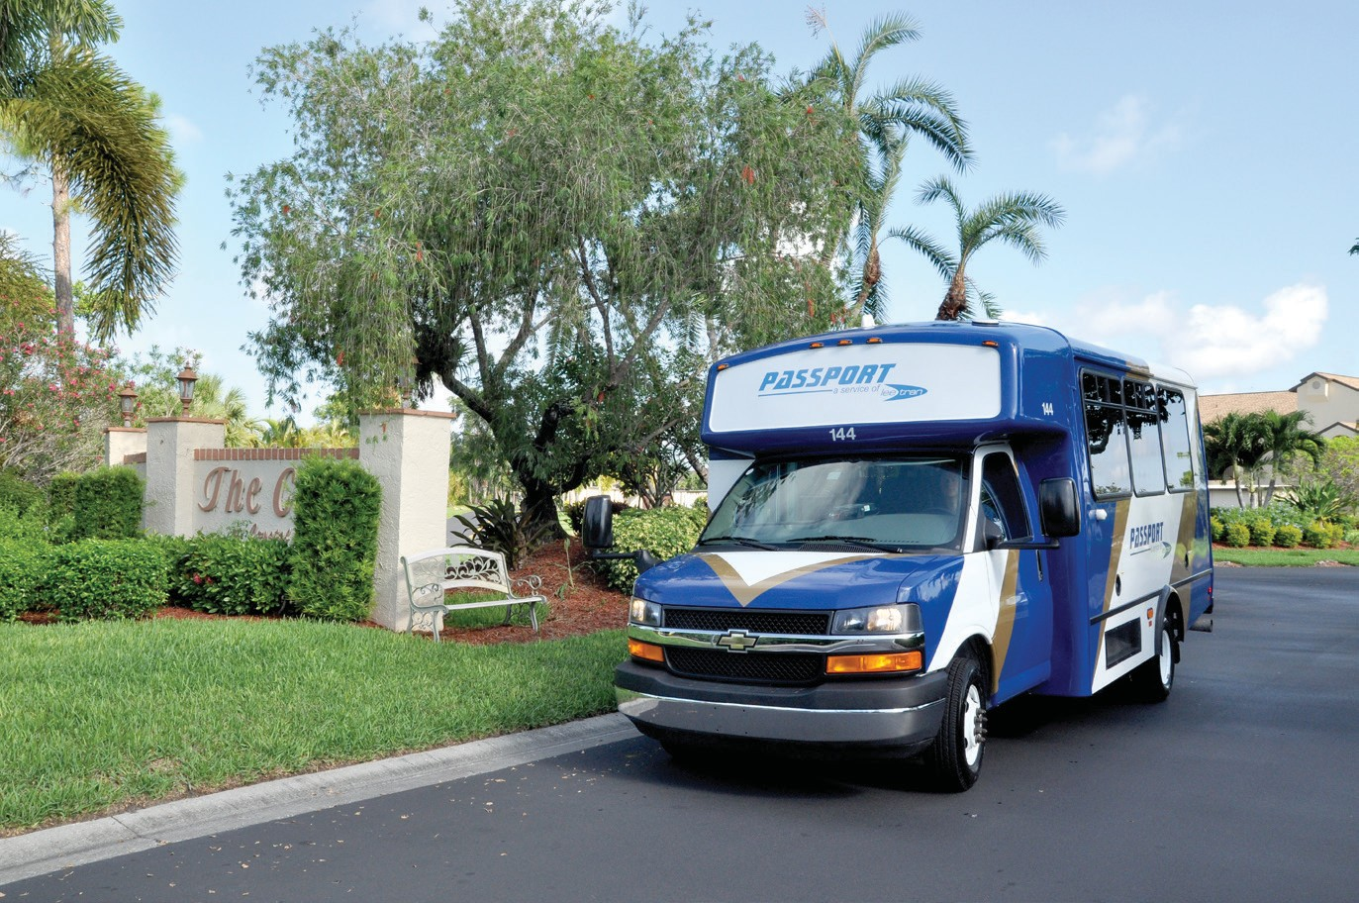

3401 Metro Parkway Fort Myers, FL 33901 Fax: 239.432.2035
Florida Relay Service-Dial 711 for TTY assistance and other available services.

Accessible format is available upon request.

Revised 12/1/2016

