Traffic Count Report

2015

Prepared by:
Lee County Department of Transportation
1500 Monroe Street
Fort Myers, Florida 33901

February 2015

2015 TRAFFIC COUNT REPORT

Prepared by:
Lee County, Florida
Department of Transportation
1500 Monroe Street
Fort Myers, Florida 33901

https://www.leegov.com/dot/traffic/trafficcountreports

February 2015
2015 TRAFFIC COUNT REPORT

Introduction
This report is intended to provide the user with information concerning the traffic volumes on major roadways in Lee County from January 2015 through December 2015, and with historical data that may be useful in estimating future traffic volumes.

Traffic characteristics at permanent count stations are detailed with monthly, daily, and hourly factors where available. Periodic Count Locations were each counted for a 72 hour period once during the year.
Lee County DOT operated 91 permanent count stations and counted at 58 periodic count sites in 2015.

Traffic count data was processed by Midwest Solutions consulting group. Average Annual Daily Traffic at tube count locations were calculated using nearby count stations to develop daily and monthly factors. Average Annual Daily Traffic at permanent count stations were developed by dividing total volume by number of days data were collected. Traffic count details are available at http://www.ms2soft.com/tcds/tsearch.asp?loc=Lee&mod=.

Construction Activity
Roadway construction, especially major projects, can affect traffic flow and driving patterns for many miles from the project site and on many roads other than the one under construction. Although traffic counts are not collected in areas actively under construction, counts nearby may have been affected by the construction. No judgment is made on how much impact, if any, the construction may have had on a particular count. The user of these data should be aware the impact construction activity has on travel patterns. Users of this report should use their professional judgment to determine the applicability of these data to the study being performed.

The new permanent count stations were added as part of the Countywide ATMS project. Since the project came on line during the year, only partial data is available for these sites.

Availability of Report
This report is available online at https://www.leegov.com/dot/traffic/trafficcountreports

Permanent Count Station
Data
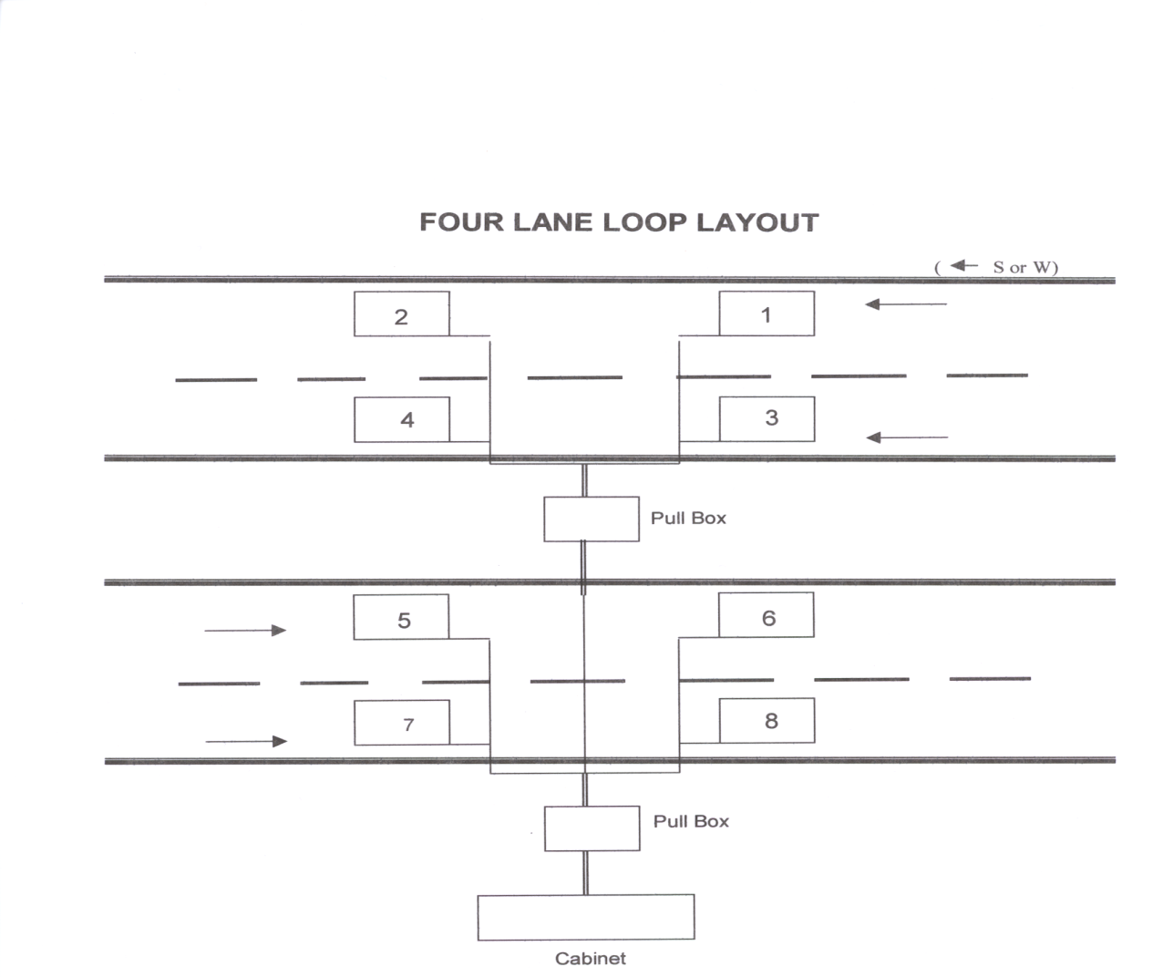
Permanent Count Station Data

The following is a summary of the traffic characteristics at each of the 91 permanent count stations used to factor the periodic count locations in Lee County. The user may find this information helpful in interpreting raw traffic counts that may be collected for specific applications.

Construction activity and equipment failures may have caused some permanent count stations to produce inadequate data at various times. Where no monthly factor is available for the current year, a monthly factor from a previous year was used to adjust the raw data to estimate the AADT for periodic count stations. If an entire year’s data are not available, use the factors and directional split data provided with caution. For some permanent count station, there was not enough data to develop factors. For those stations, the adjusted AADT is included in the summary spreadsheet, but individual sheets are not included.

The following is a list of permanent count stations:
Loc ID | On | Approach | At
1 | US-41 (SR 45) | NORTH OF | NORTH KEY DR
2 | DEL PRADO BLVD | SOUTH OF | CORNWALLIS
3 | PINE ISLAND RD | WEST OF | MATLACHA
5 | PALM BEACH BLVD (SR 80) | WEST OF | SR 31
6 | HOMESTEAD RD | AT | WESTMINSTER
7 | BONITA BEACH RD | EAST OF | VANDERBILT RD
8 | SAN CARLOS BLVD (SR 865) | SOUTH OF | PRESCOTT ST
9 | US-41 (SR 45) | NORTH OF | BRANTLEY RD
10 | ALICO RD | WEST OF | I 75
11 | BUCKINGHAM RD | SOUTH OF | PALM BEACH BLVD
12 | BURNT STORE RD | SOUTH OF | CHARLOTTE CO
13 | CAPE CORAL PKWY | EAST OF | SKYLINE BLVD
14 | COLONIAL BLVD (CR 884) | EAST OF | SUMMERLIN RD
15 | CORKSCREW RD (CR 850) | WEST OF | I 75
16 | OLD 41 RD | NORTH OF | COLLIER CO LINE
17 | HANCOCK BRIDGE PKWY | WEST OF | BEAU DR
18 | SIX MILE PKWY | NORTH OF | WINKLER AVE
19 | SUMMERLIN RD (CR 869) | WEST OF | WINKLER RD
20 | DR. M. L. KING JR BLVD (SR 82) | WEST OF | I 75
21 | IMMOKALEE RD (SR 82) | EAST OF | GUNNERY RD
22 | LEE BLVD (SR 884) | WEST OF | GUNNERY RD
23 | US-41 (SR 45) | NORTH OF | COLLIER CO LINE
25 | US-41 (SR 45) | SOUTH OF | HICKORY DR
27 | STRINGFELLOW RD | NORTH OF | CASTILE RD
28 | FOWLER ST | SOUTH OF | HANSON ST
29 | McGregor BLVD (SR 867) | NORTH OF | MANUELS DR
30 | DANIELS PKWY | WEST OF | METRO PKWY
31 | DANIELS PKWY | EAST OF | SIX MILE CYPRESS PKWY
33 | CHAMBERLIN PKWY | SOUTH OF | DANIELS PKWY
34 | PONDELLA RD | EAST OF | BETMAR
35 | SUMMERLIN RD (CR 869) | SOUTH OF | PARK MEADOWS
36 | SUMMERLIN RD (CR 869) | EAST OF | JOHN MORRIS
37 | McGREGOR BLVD (SR 867) | SOUTH OF | PINE RIDGE
38 | McGREGOR BLVD (CR 867) | NORTH OF | KELLY RD
39 | GLADIOLUS DR | EAST OF | A&W BULB RD
40 | DEL PRADO BLVD | North of | FOUR MILE COVE RD
41 | TAMIAMI TRAIL (SR 739) | NORTH OF | EDISON BRIDGE
42 | BONITA BEACH RD | WEST OF | I-75
43 | COLLEGE PKWY | EAST OF | WINKLER RD
44 | ESTERO BLVD | NORTH OF | DONORA BLVD
45 | METRO PKWY | NORTH OF | ARC WAY
46 | GLADIOLUS DR | WEST OF | US 41
47 | GLADIOLUS DR | EAST OF | WINKLER RD
48 | DANIELS PKWY | EAST OF | CHAMBERLIN
49 | PINE ISLAND RD | EAST OF | PONDELLA RD
50 | VETERANS PKWY | WEST OF | AVIATION BV
52 | DANIELS PKWY | EAST OF | I-75
53 | ALICO RD | WEST OF | BEN HILL GRIFFIN PKWY
54 | SANTA BARBARA BLVD | SOUTH OF | SE 22ND TERR
55 | SANTA BARBARA BLVD | NORTH OF | SE 28TH ST
56 | CAPE CORAL PKWY | WEST OF | PALM TREE BLVD
57 | PINE ISLAND RD | EAST OF | SW 19TH AVE
58 | CHIQUITA BLVD | NORTH OF | SW 27TH ST
60 | BEN HILL GRIFFIN PKWY | SOUTH OF | TERMINAL RD
61 | TREELINE AVE | NORTH OF | TERMINAL RD
62 | TREELINE AVE | SOUTH OF | Pelican Preserve Blvd
63 | Imperial Pkwy | North of | Strike Ln
64 | Bayshore Rd | EAST OF | First St
66 | Summerlin Rd | South of | University Blvd
68 | DR. M. L. KING JR BLVD (SR 82) | EAST OF | I 75
70 | Corkscrew Rd | East of | Miramar Outlets Driveway
71 | BEN HILL GRIFFIN PKWY | NORTH OF | ESTERO PKWY
72 | Three Oaks Pkwy | SOUTH OF | ESTERO PKWY
73 | Cypress Lake Dr | EAST OF | Overlook Dr
74 | Summerlin Rd | NORTH OF | Matthew Dr
77 | Tamiami Trail | SOUTH OF | PINE ISLAND RD
81 | Cypress Lake Dr | EAST OF | South Pointe Blvd
89 | DANIELS PKWY | WEST OF | Gateway Blvd
92 | US 41 | NORTH OF | BONITA BEACH RD
94 | US 41 | NORTH OF | Constitution Blvd
95 | US 41 | NORTH OF | Andrea Lane
96 | US 41 | NORTH OF | Boy Scout Dr
97 | US 41 | NORTH OF | Winkler Ave
103 | US 41 | SOUTH OF | Tara Woods Blvd
104 | Bayshore Rd | WEST OF | Hart rd
108 | PINE ISLAND RD | EAST OF | Merchants Xing
120 | Sanibel Toll Plaza
121 | Midpoint Toll Plaza
122 | Cape Toll Plaza

