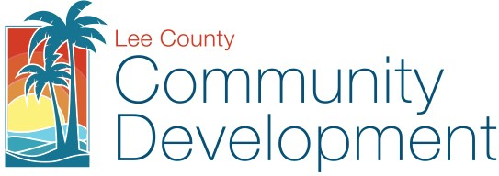
Lee County Board of County Commissioners Department of Community Development, Planning Section
P. O. Box 398 Fort Myers Fl 33902-0398 Telephone: (239) 533-8585

REQUEST TO EXPEDITE APPLICATION PROCESSING
FOR PROJECTS PROVIDING ON-SITE BUILT AFFORDABLE HOUSING UNITS

Project Name: Project Location: Project STRAP No.: Expedited Request for Case/ Permit Number:

Total number of very- low and low income housing units Total number of homeowner and/or rental units
Total number of single family or multi-family units

Applicant /Agent: Address:

City/State: Phone:
Zip: E-Mail:

Is the project currently receiving SHIP, HOME, CDBG or Tax Credit funding? If yes, what type and what is the income monitoring requirement?

Under penalties of perjury, I declare that I have read the foregoing Request to Expedite Application Processing and that the facts stated in it are true.

Signature Date

STATE OF FLORIDA COUNTY OF LEE

The foregoing instrument was sworn to (or affirmed) and subscribed before me by means of ☐ physical presence or ☐ online notarization on (date) by (name of person providing oath or affirmation), who is personally known to me or who has produced
(type of identification) as identification.

Signature of Notary Public
STAMP/SEAL STAFF USE ONLY
APPROVED:
DENIED: for the following reasons:

CERTIFIED BY: Date:
Note: Approval of the Request to Expedite Application Processing does not guarantee project approval.
Request to Expedite Application Processing for Projects Providing On-Site Built Affordable Housing Units (5/13/2021)

